Studio Music Player

User’s Guide



[Image by vectorpouch on Freepik](%3ca%20href=%22https:/www.freepik.com/free-vector/tango-ballroom-illustration-man-woman-red-dress-dancing-latin-american-dance_2890926.htm#query=ballroom%20dance&position=3&from_view=keyword&track=ais">Image by vectorpouch</a> on Freepik)

Version 1.4

23 May 2023

TAble of Contents

INTRODUCTION 1

Installation 1

Windows 1

macOS 1

Starting the program 1

Windows 1

macOS 1

INITIAL SCREEN 2

Login 2

Create Account 3

HOME PAGE 4

Change Password 5

USING MUSIC ON THIS DEVICE 6

Navigation Bar 6

Songs on this Device 6

Filtering Songs 7

Adding Songs to the device 9

Songs without Cover Art 10

Song Actions 11

Playing a single song 11

Editing song metadata 12

Playlists on this Device 16

Playlist Categories 16

Your Playlists 17

Create an Empty Playlist 18

Create a Random Playlist 19

Create a Showcase Playlist 21

Copying a Playlist 22

Editing a Playlist 23

Adding Random Songs to a Playlist 23

Adding a Selected Song to a Playlist 24

Random Replacement of a Playlist Song 26

Selected Replacement of a Playlist Song 27

Deleting a Song from a Playlist 28

Replacing All Songs in a Playlist 29

Shuffle a Playlist 29

Move songs in a playlist with drag and drop 30

Addtional playlist editing notes 32

Stop editing the playlist 32

Starting a playlist 32

STREAMING FROM SPOTIFY 38

Sign in to Spotify 38

Find tracks on Spotify 40

List of Figures

Figure 1 – SMP Startup Screen 2

Figure 2 – Enter Login Credentials 2

Figure 3 - Select account type 3

Figure 4 - Creating a teacher account 3

Figure 5 - SMP Home Page 4

Figure 6 - Change User Password 5

Figure 7 - Navigation Bar (local audio) 6

Figure 8 – All songs on this device 6

Figure 9 – Songs filtered by title 7

Figure 10 – Songs filtered by artist 7

Figure 11 – Selecting a dance type for a group class 8

Figure 12 – Songs filtered by dance type 8

Figure 13 - Add Song from File 9

Figure 14 - Selecting audio file and dance type 9

Figure 15 - Audio file added to Songs list 10

Figure 16 - Songs without cover art 10

Figure 17 - Single Song Audio Player 11

Figure 18 - Edit song info 12

Figure 19 - Editing song without cover art 13

Figure 20 - Browser tab with image search 13

Figure 21 – View filtered to show modified song 14

Figure 22 - Unable to access Spotify 14

Figure 23 - BMP value extracted from Spotify 15

Figure 24 - Spotify tracks with matching titles 15

Figure 25 - BMP value extracted from selected track 16

Figure 26 - Playlist dropdown menu 16

Figure 27 - Table of Playlists owned by the current user 17

Figure 28 - Create Empty Playlist Form 18

Figure 29 – Changing playlist information 18

Figure 30 - Create Random Playlist part 1 19

Figure 31 – Create Random Playlist part 2 19

Figure 32 - Incorrect number of songs 20

Figure 33 - User Playlists prior to copying 22

Figure 34 - User playlist after copying 22

Figure 35 - Editing an empty playlist 23

Figure 36 – Add Random Song pulldown menu 24

Figure 37 - Random song added to playlist 24

Figure 38 - Adding a song to playlist 25

Figure 39 – Selected song added to playlist 25

Figure 40 - Change Song pulldown menu 26

Figure 41 - Replace playlist entry with random song 26

Figure 42 - Selecting a replacement song 27

Figure 43 - Replace playlist entry with selected song 27

Figure 44 - Confirm intention to delete song 28

Figure 45 - Song deleted from Playlist 28

Figure 46 - Playlist after all songs replaced 29

Figure 47 – Playlist after shuffling songs 30

Figure 48 - Selecting a song to move within the playlist 31

Figure 49 – Dragging the song toward its new position 31

Figure 50 - Dropping the song at its new position 32

Figure 51 – Party Playlist player 33

Figure 52 - Normal Playlist Player 34

Figure 53 - Showcase Playlist Player 35

Figure 54 – Showcase Player paused between songs – hit Play to continue 36

Figure 55 - Feature Songs in a showcase playlist 37

Figure 56 - Enter Spotify credentials 38

Figure 57 - Allowing access to Spotify account 39

Figure 58 - List of Liked Songs on Spotify 40

# INTRODUCTION

**Studio Music Player** (SMP) is a software application for ballroom studios. Both Microsoft Windows and MacOS are supported.

Users can import music files, assign a suggested dance style to each song, and create playlists from those songs. Playlists or individual songs can be played, and the suggested dance style for the current song will be displayed.

The SMP application has two modes of operation:

1. It can play audio files stored on the local device
2. if the user has a Spotify account and a live internet connection, it can stream tracks from Spotify

## Installation

### Windows

This section to be added in the future.

### macOS

This section to be added in the future.

## Starting the program

### Windows

An icon named “**StudioMusicPlayer.bat**” was added to the desktop during installation. Double-click the icon to start the SMP application.

The Firefox browser will be launched and it will connect to the SMP application using <http://localhost:8000>

### macOS

This section to be added in the future.

# INITIAL SCREEN

Once the application is started, the browser displays the screen shown in Figure 1. From this screen, users can log in to the application or create a new account.

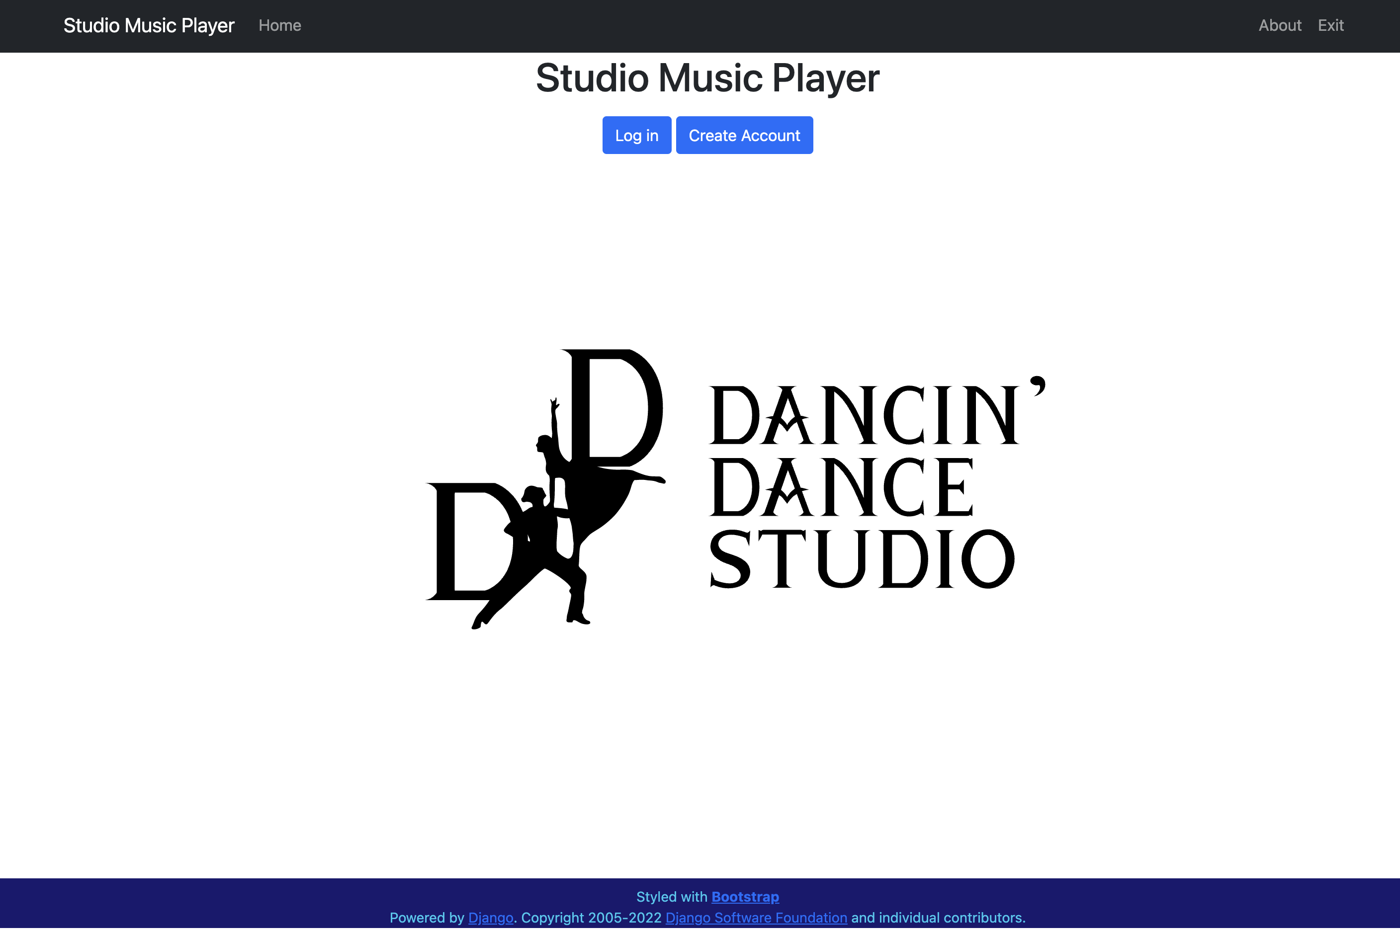

Figure 1 – SMP Startup Screen

## Login

If the user has established an account, they may click the Log in button on Figure 1. The screen in Figure 2 is shown. Once the user has entered their Username and Password, they may click the Log in button to continue.

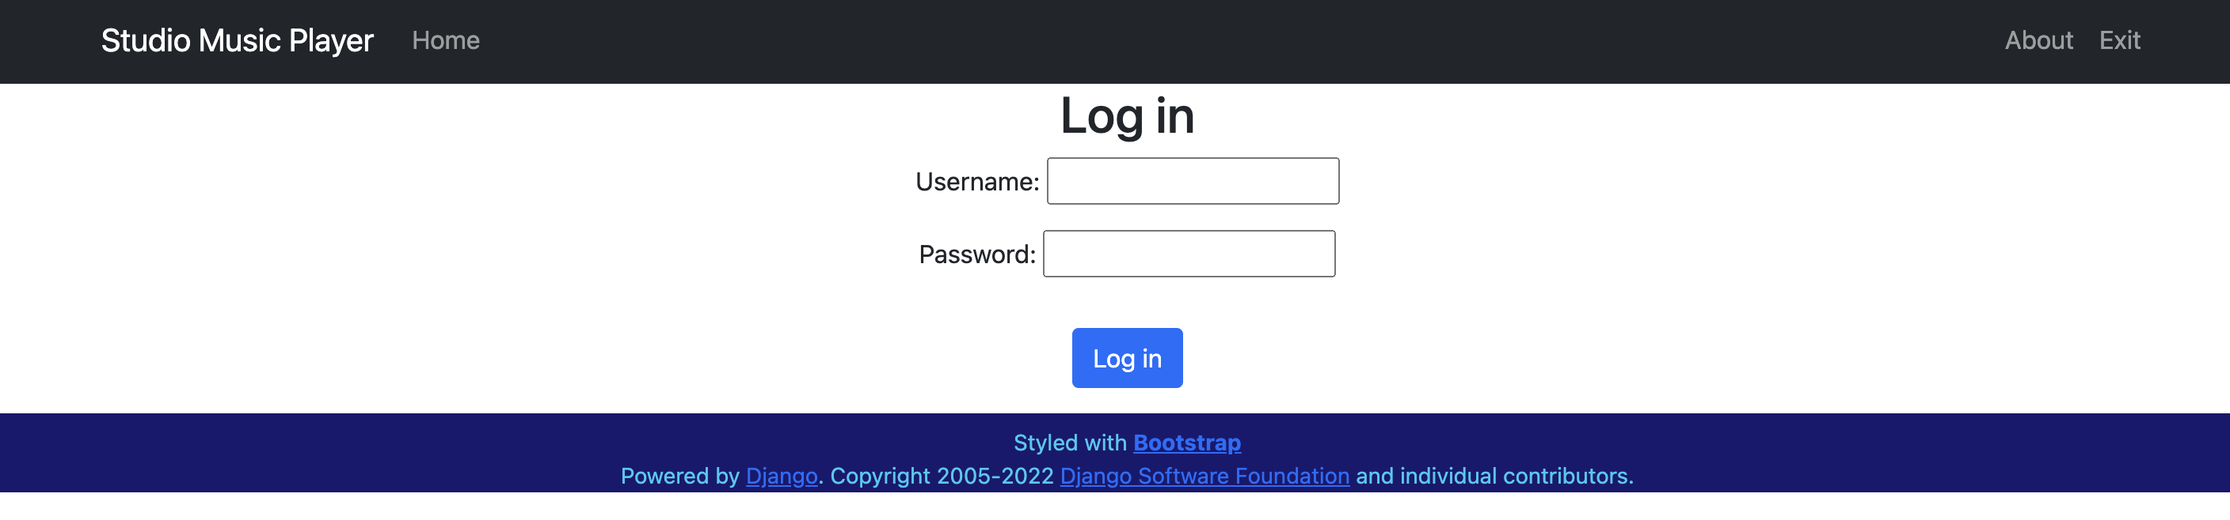

Figure 2 – Enter Login Credentials

Once the user is logged in, they are redirected to the Home Page.

## Create Account

If the user clicks the Create Account button, the page shown in Figure 3 is displayed. The user must select the I’m a teacher button to create their account. Guest accounts are currently not supported and may be added in the future.

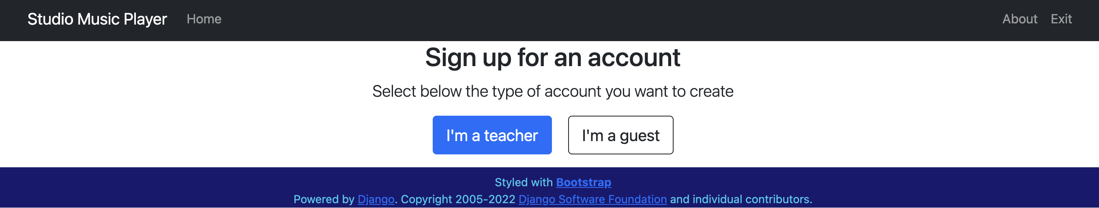

Figure 3 - Select account type

When the user selects the I’m a teacher button, the page in Figure 4 is displayed. The user enters a username and password, types the password a second time to confirm and then clicks the Sign up button.

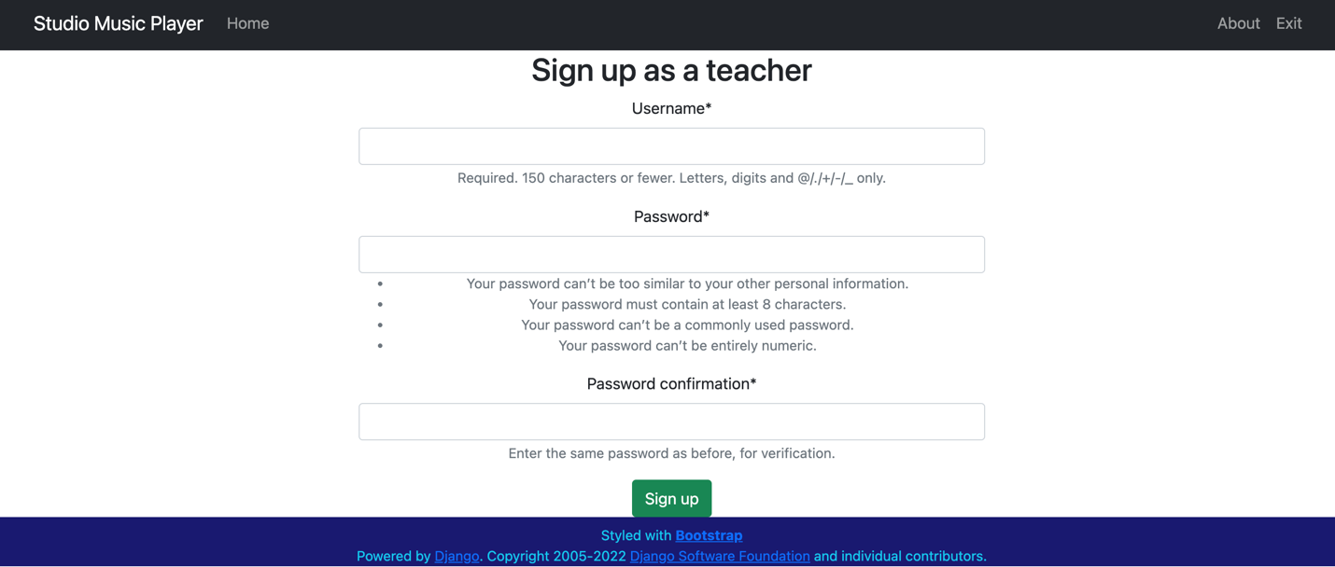

Figure 4 - Creating a teacher account

Once the account is created, the user is redirected to the Home Page.

# HOME PAGE

Once the user has successfully logged in, the application will display the home page as shown in Figure 5.

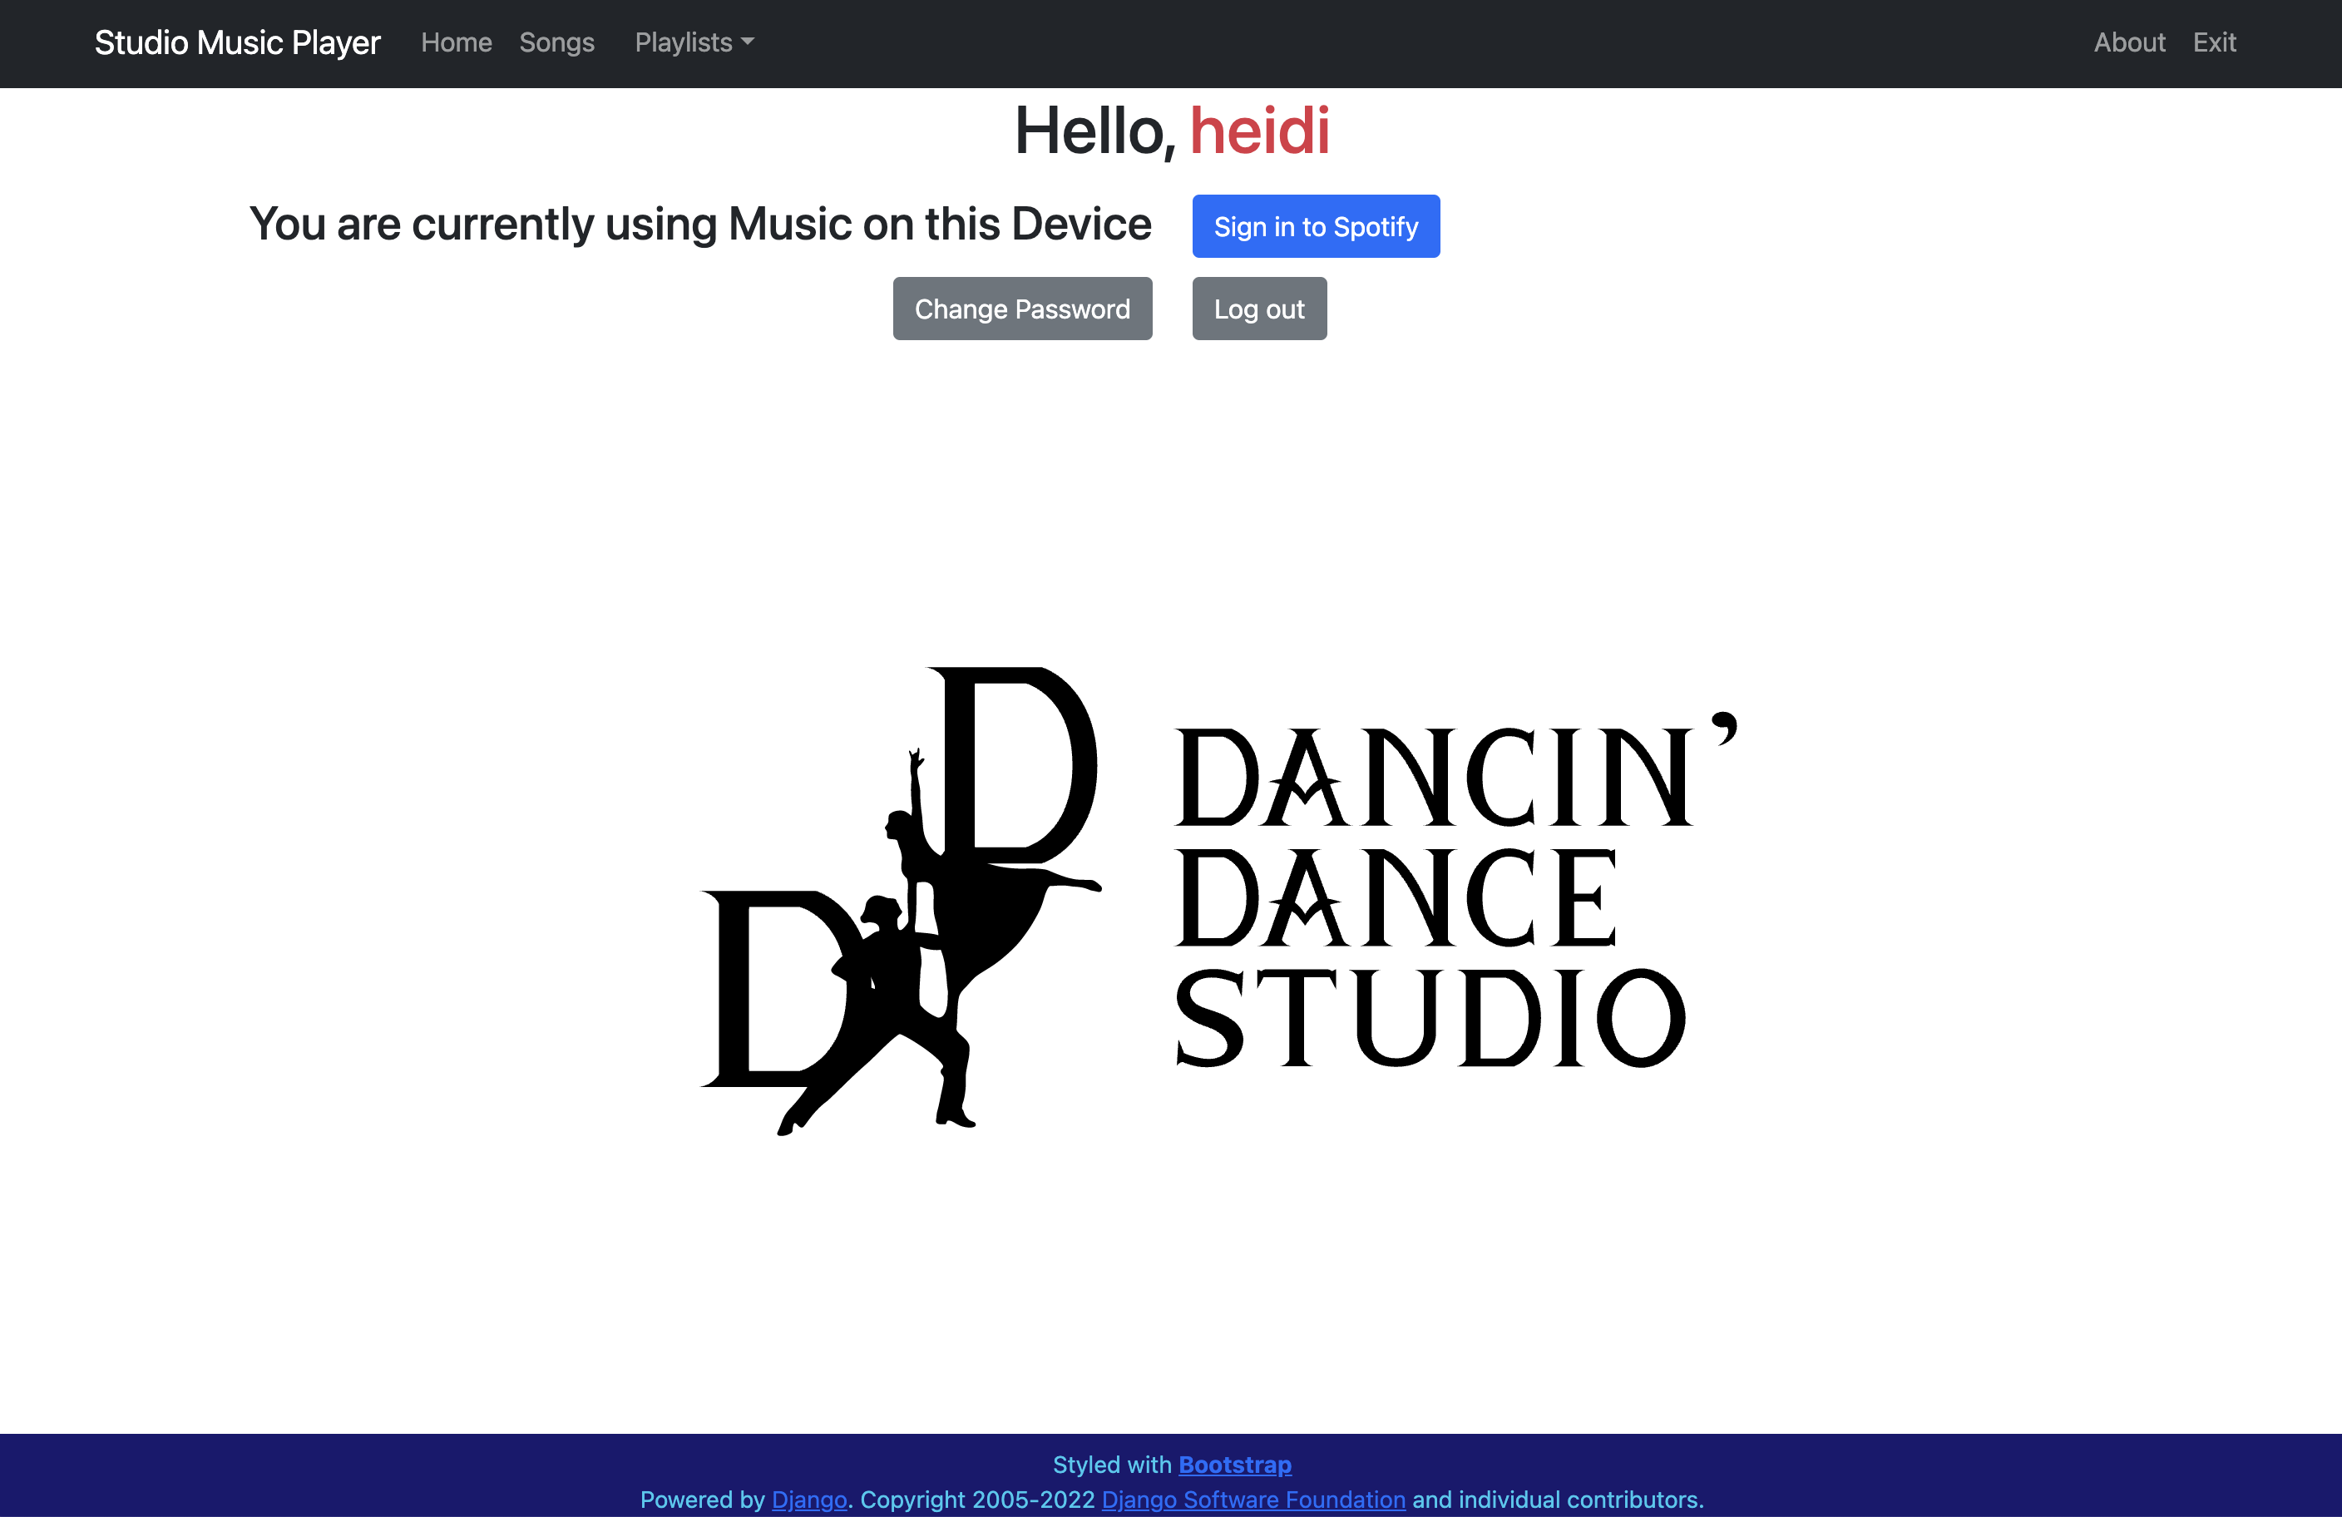

Figure 5 - SMP Home Page

The home page indicates the current mode (using Music on this Device or Streaming from Spotify). The user may change the current mode by clicking the Sign in to Spotify button. If the user is streaming from Spotify, that button will read Use Music from Local Device.

The user may select Change Password to modify their SMP login credentials.

If the user selects Log out, the SMP application returns to the Initial Screen.

## Change Password

To change their password, the user must enter their old password, a new password that conforms to the rules shown in Figure 6, confirm their new password by entering it a second time and hitting the Save button.

If the user has forgotten their password, contact the system administrator in order to reset it.

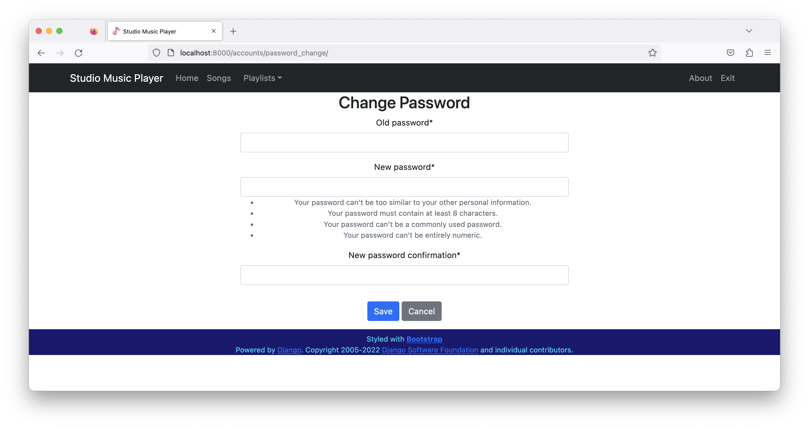

Figure 6 - Change User Password

# USING MUSIC ON THIS DEVICE

## Navigation Bar

All screens displayed by the StudioMusicPlayer have a navigation bar as shown in Figure 7. The menu selections are as follows:

* Home – returns to the Home Page
* Songs – work with individual audio files
* Playlists – work with playlists
* About – display version information
* Exit – quit the application



Figure 7 - Navigation Bar (local audio)

## Songs on this Device

This screen displays a table of all audio files loaded into the application on this device, as shown in Figure 8. For each song, the Title, Artist, suggested Dance type, and tempo in Beats Per Minute (BPM) are displayed. The songs are sorted by title, and the user can scroll up and down as necessary.

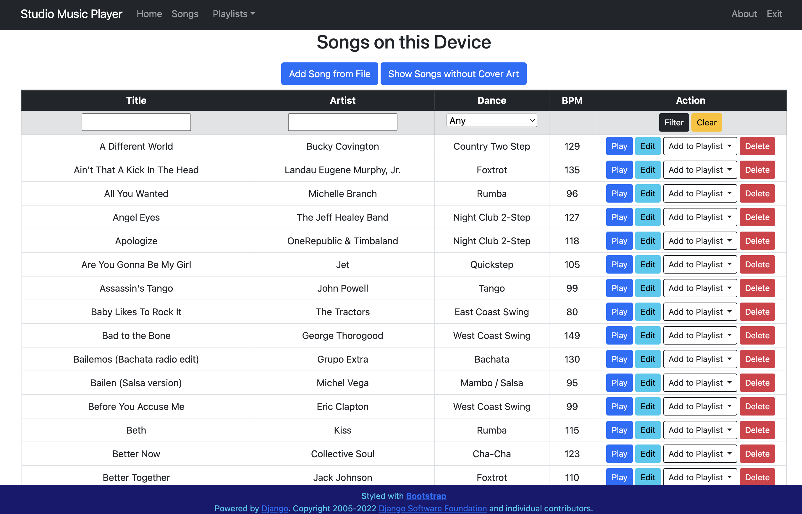

Figure 8 – All songs on this device

### Filtering Songs

Although the user can scroll to locate a song of interest, it can be easier to use the filtering feature.

To filter songs by title, enter some text into the box below the Title header as shown in Figure 9. Once text has been entered, hit the Enter key or the **Filter** button.

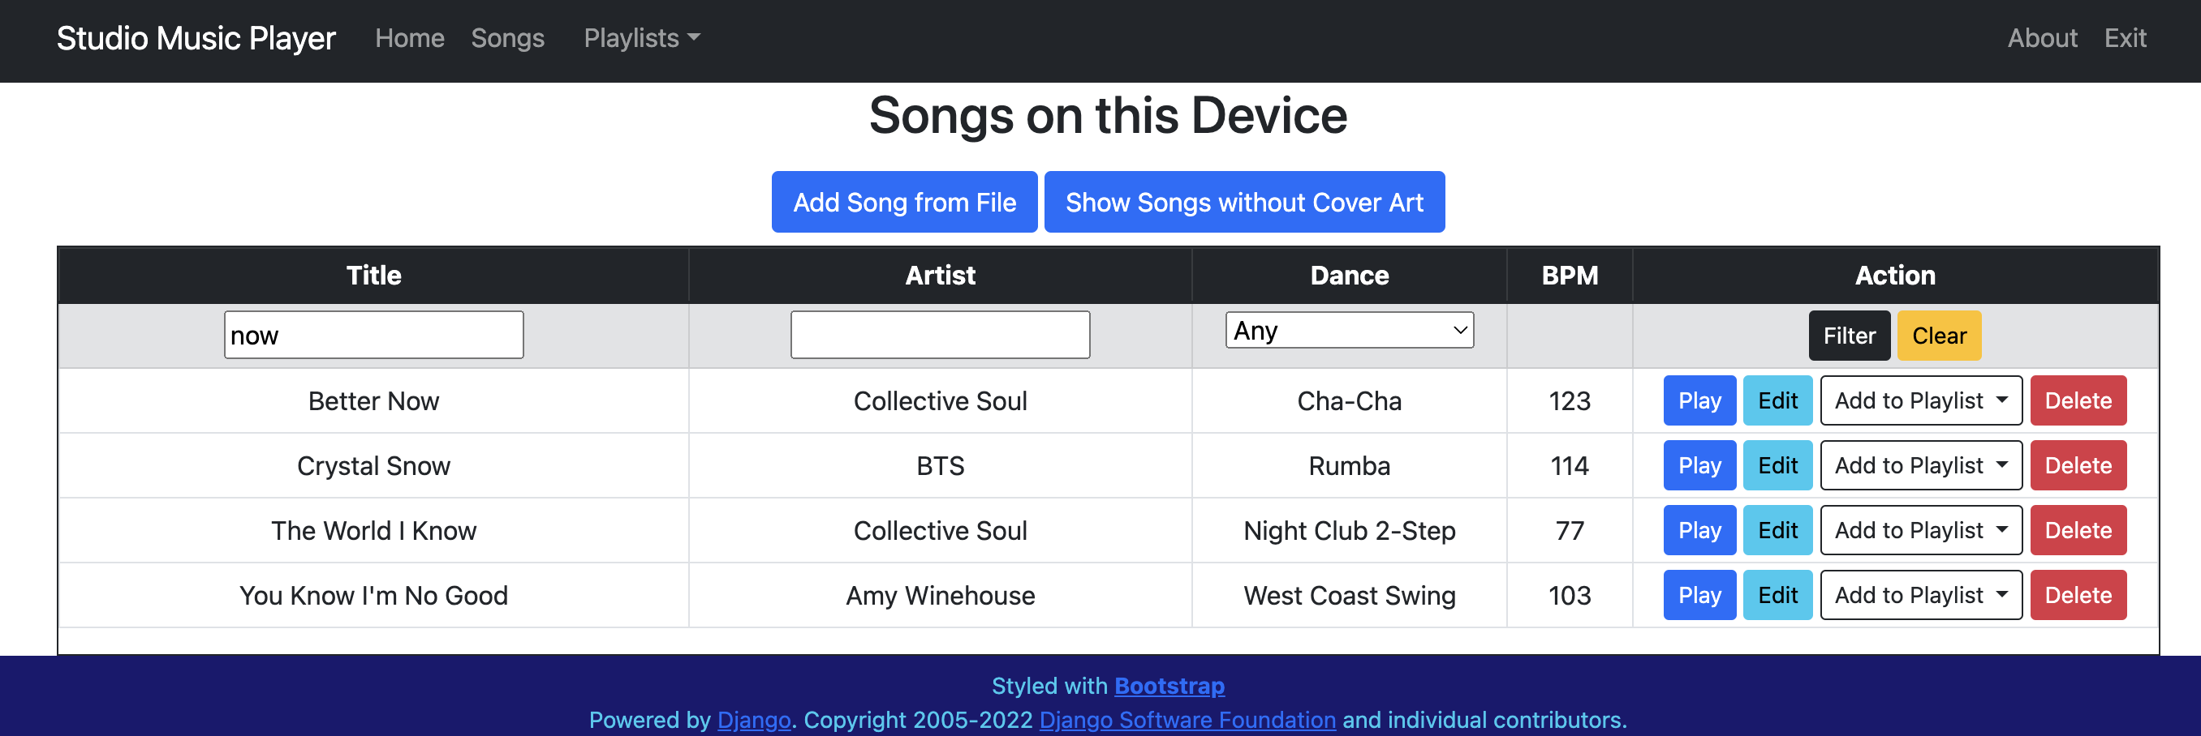

Figure 9 – Songs filtered by title

To filter songs by artist, enter some text into the box below the Artist header as shown in Figure 10. Once text has been entered, hit the Enter key or the **Filter** button.

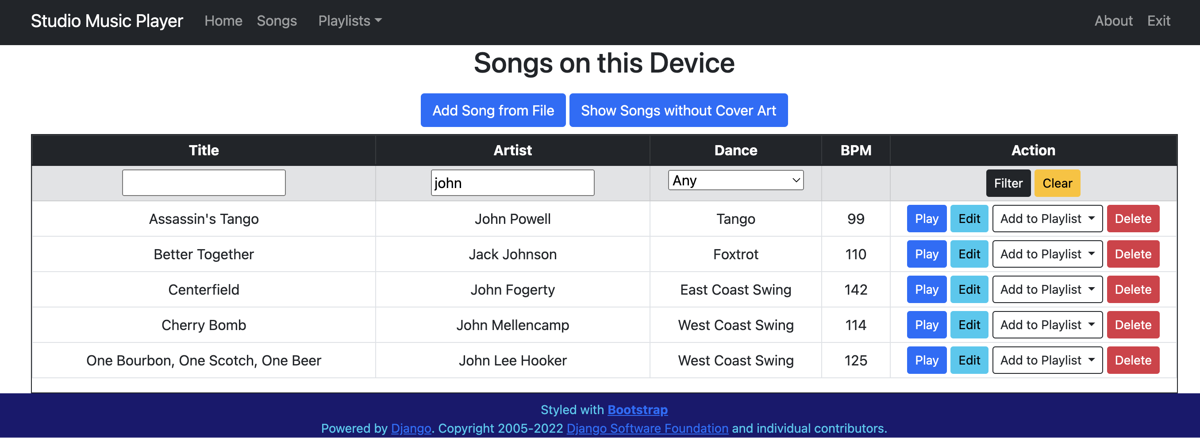

Figure 10 – Songs filtered by artist

To filter songs by dance type, click the pull-down menu below the Dance header as shown in Figure 11. Select a dance type and the matching songs will be displayed as in Figure 12. This can be useful when teaching a group class or private lessons.

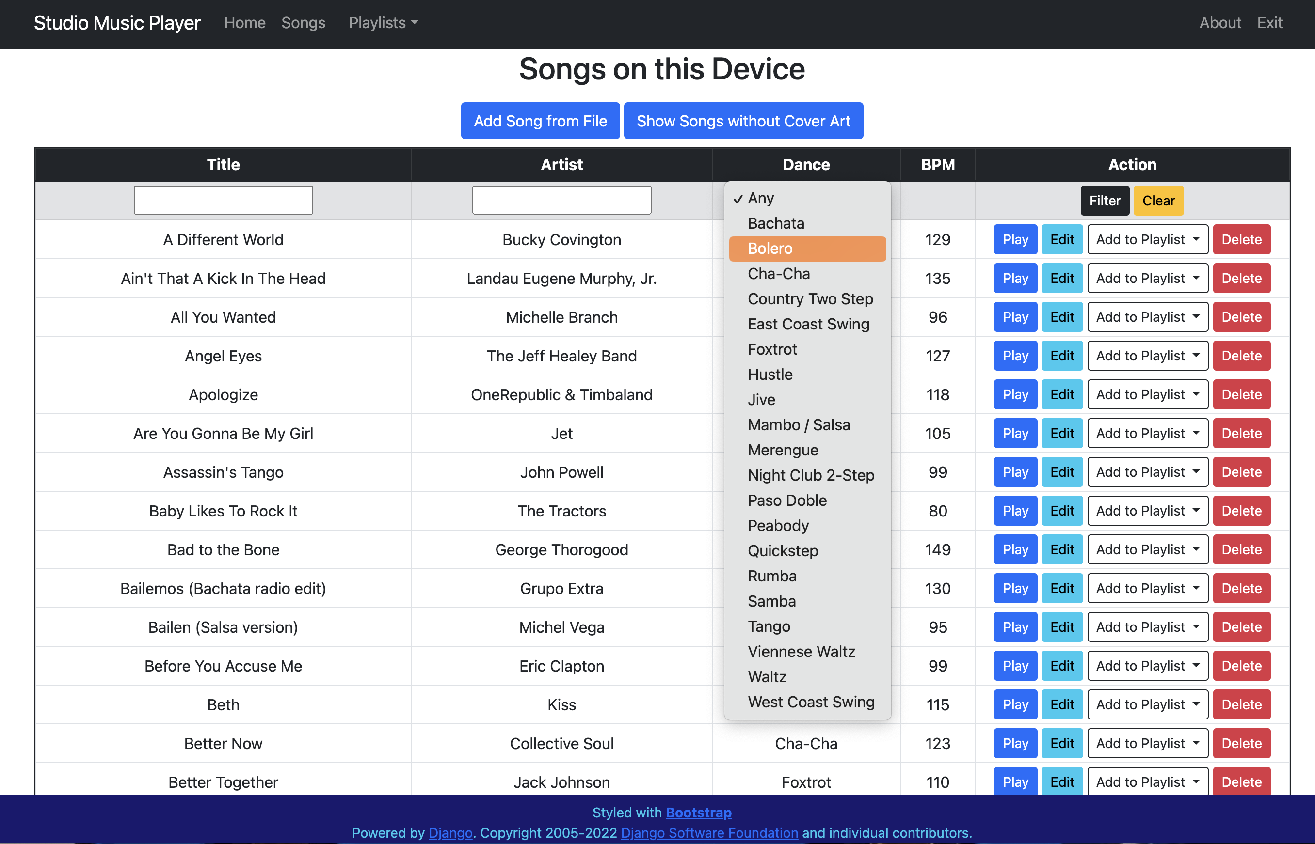

Figure 11 – Selecting a dance type for a group class

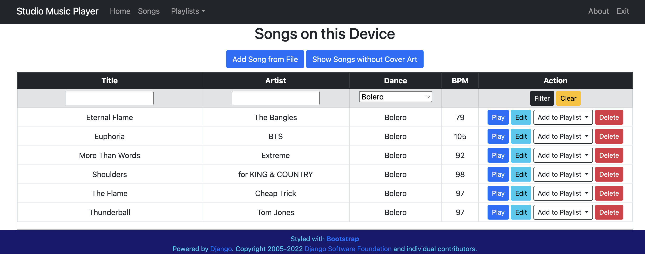

Figure 12 – Songs filtered by dance type

To remove any filters that has been applied, click the Clear button and all songs will be displayed as in Figure 8.

### Adding Songs to the device

Once an audio file has been added into the SMP application, it can be played without an active internet connection. Supported audio formats include M4A, MP3, WAV, FLAC and Ogg/Vorbis. Protected audio formats such as M4P are not supported.

To add an audio file into the SMP application, click the Add Song from File button on the Songs page. The Add Song page will be displayed as shown in Figure 13.

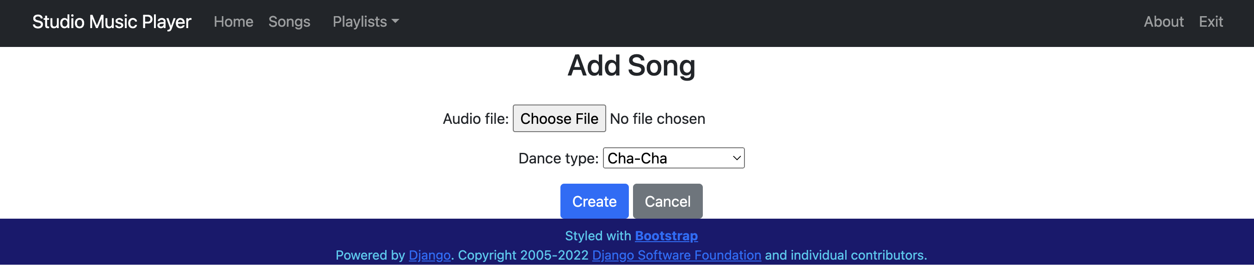

Figure 13 - Add Song from File

Click the Choose File button to browse for the audio file. Once the audio file has been chosen, use the pulldown menu to select a Dance type. Once the selections have been made, as shown in Figure 14, the user then clicks the Create button to process the file.

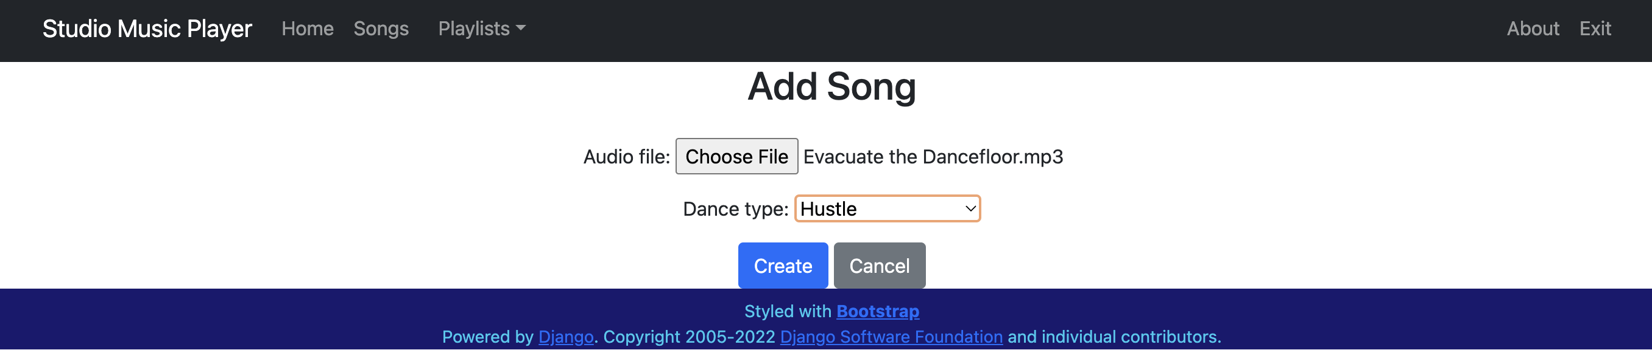

Figure 14 - Selecting audio file and dance type

The audio file will be copied into a folder under the SMP application. The audio file will be searched for metadata (title, artist, and cover art). If the file does not contain cover art, the SMP application will attempt an internet search to find the appropriate cover art.

If the file metadata contained the title and the artist, the user will be redirected to the Songs page, filtered to the new song, as shown in Figure 15. If either the title or artist were missing from the metadata, the user will be redirected to the Edit Song Info page.

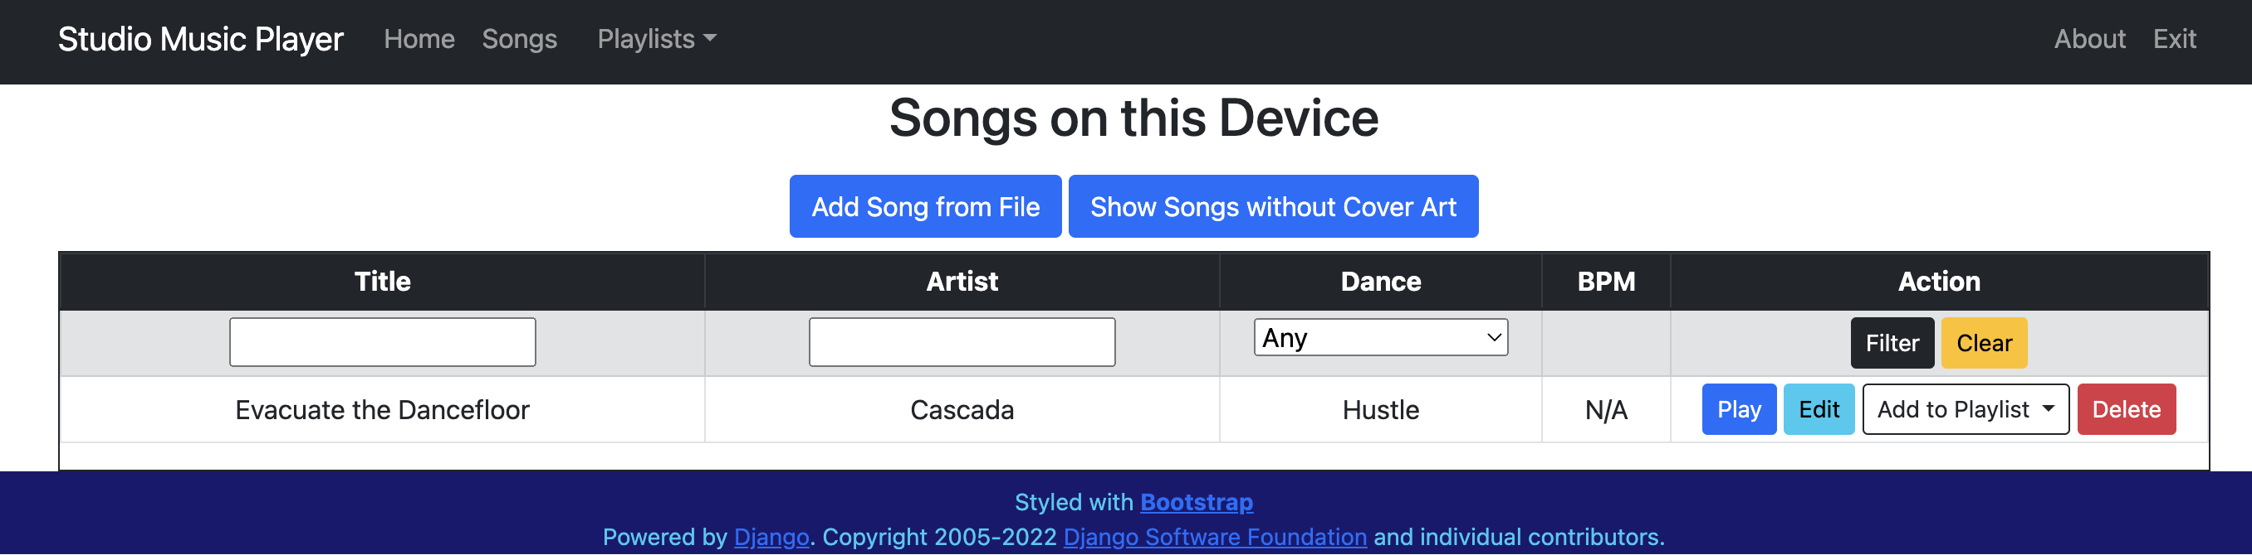

Figure 15 - Audio file added to Songs list

### Songs without Cover Art

On occasion, the SMP application will be unable to find cover art for a song, either in the metadata or from the internet search. For these songs, a default image will be used.

To identify songs without cover art, the user can click the Show Songs without Cover Art button on the Songs page. A list of songs will be displayed as shown in Figure 16.

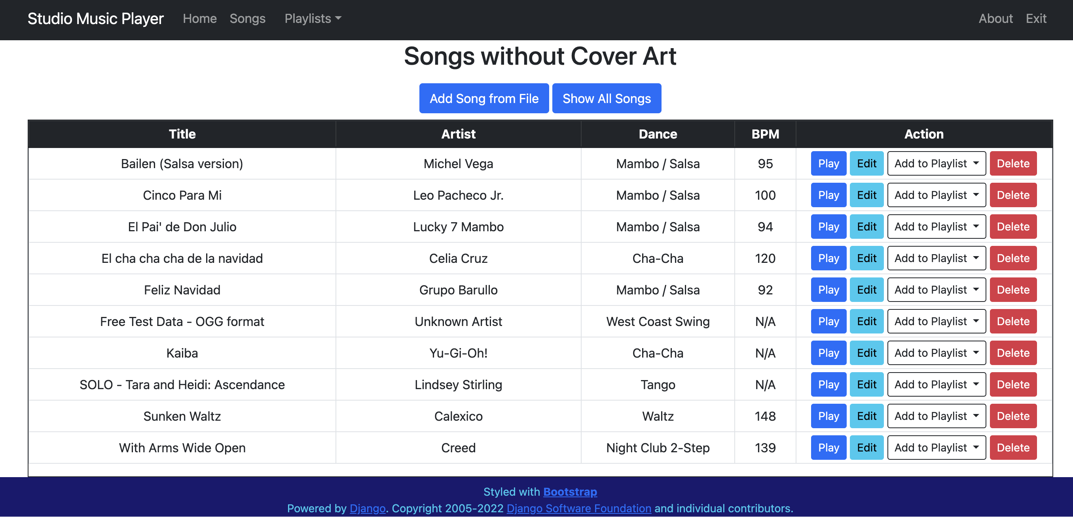

Figure 16 - Songs without cover art

### Song Actions

On all pages that show a list of songs, there are several action buttons listed for each song.

* **Play** – launches the audio player screen and plays the entire song
* **Edit** – allows the user to edit the song’s metadata and cover art
* Add to Playlist – contains a pulldown menu of the user’s playlists. The song is added to the end of the selected playlist.
* **Delete** – removes the song from the SMP application. The copy of the audio file and cover art image are deleted. This option is only available for superuser accounts.

### Playing a single song

If the user clicks the Play button from a Songs page, the single song audio player will be displayed as shown in Figure 17.

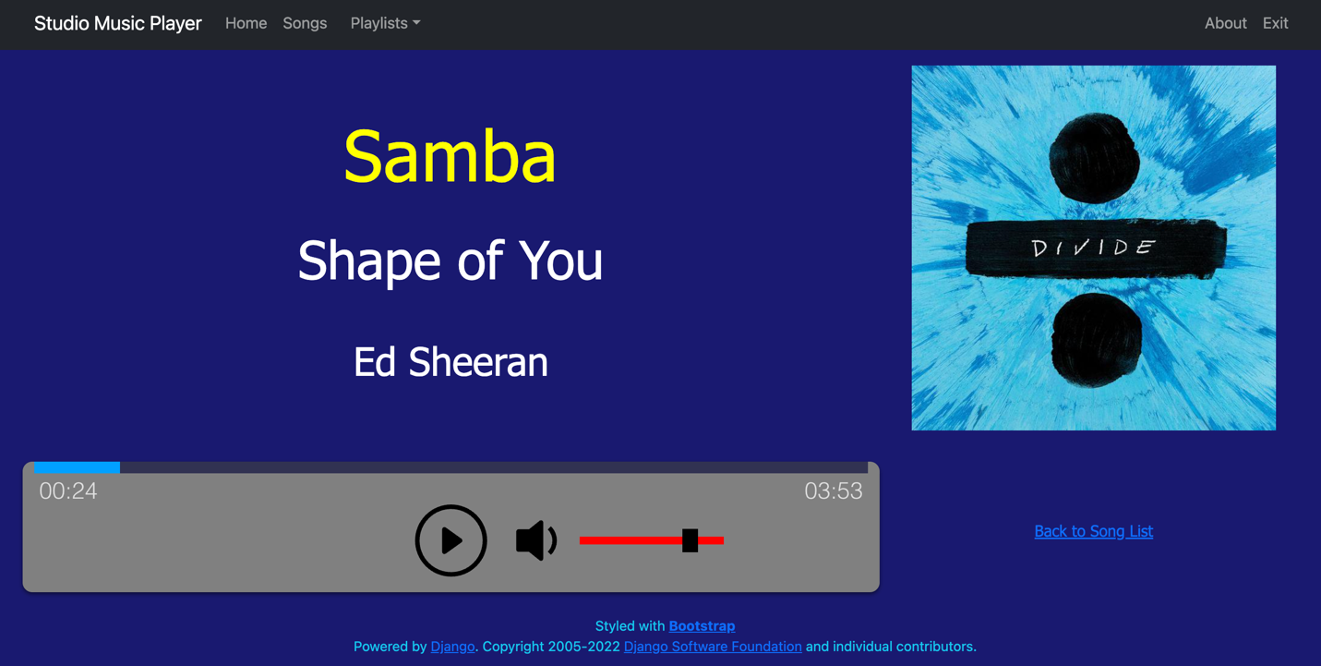

Figure 17 - Single Song Audio Player

The single song audio player has the following features and controls.

* The user can control Play or Pause by clicking the circular icon.
* The user can control the volume level by moving the box along the slider.
* The user can mute/unmute the volume by clicking the speaker icon.
* The progress bar moves from left to right as the song plays.
* The current position and total duration of the song are displayed at either end of the progress bar.
* Clicking the Back to Song List link returns the user to the Songs page.

### Editing song metadata

If the user clicks the Edit button from a Songs page, the Edit Song Info page will be displayed as shown in Figure 18.

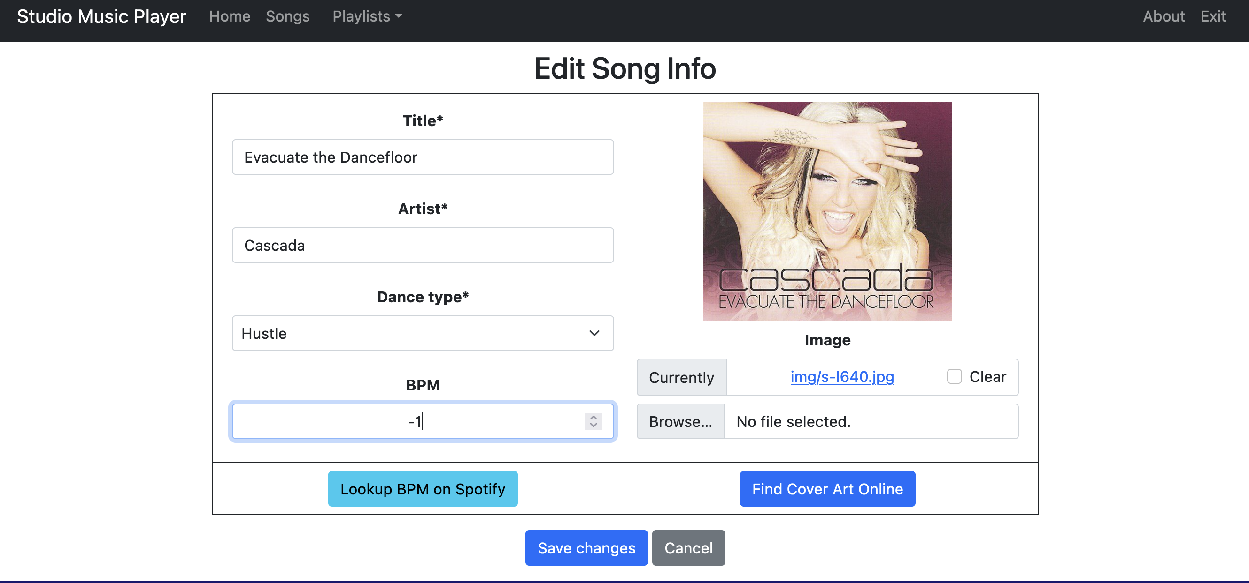

Figure 18 - Edit song info

From this page, the user may enter new text into the Title or Artist fields, change the Dance type by using the pulldown menu or entering a new tempo number into the BPM field.

If the song being edited has no cover art, a default image is displayed, as shown in Figure 19. If you have an image file to use as cover art, click the Choose File button to browse for the file. To search online for cover art, click the Find Cover Art Online button.

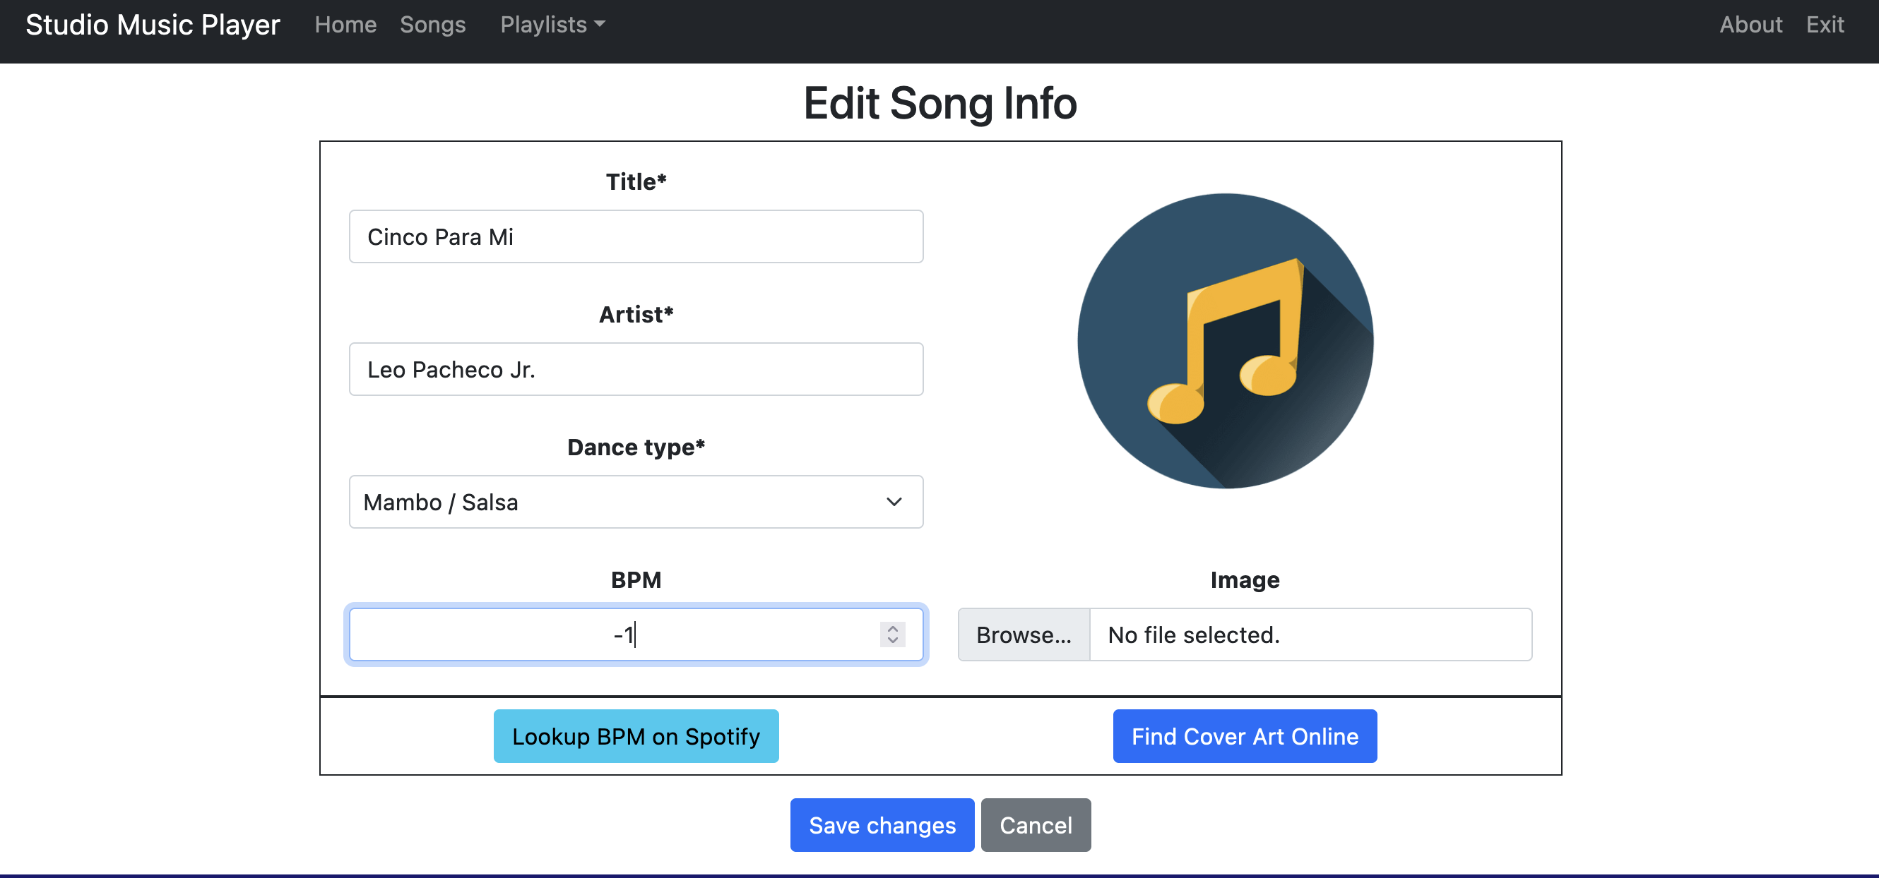

Figure 19 - Editing song without cover art

To search online for cover art, click the Find Cover Art Online button. If a match is not found programmatically, a new browser tab that searches for images based on the song artist and title will be opened as shown in Figure 20.

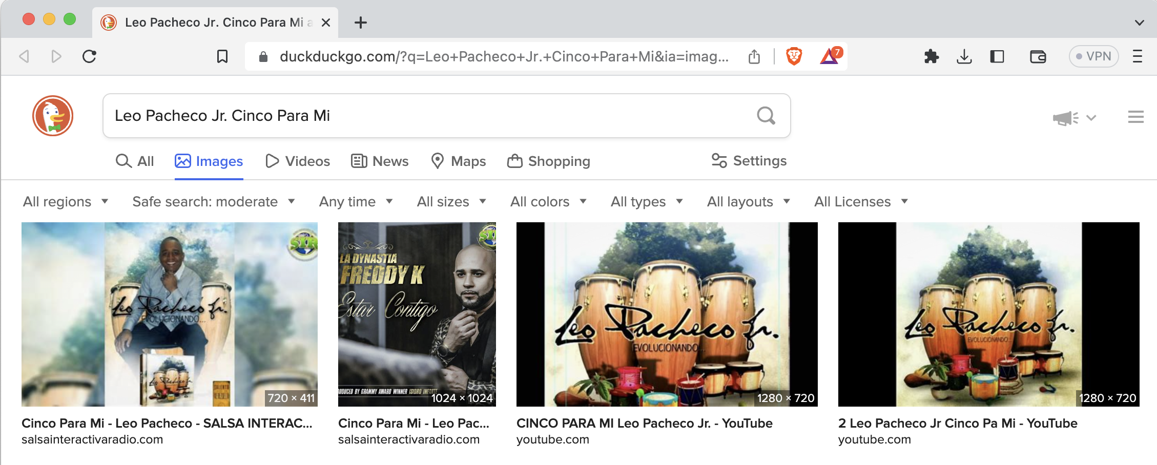

Figure 20 - Browser tab with image search

Once all desired fields have been modified, click the Save changes button to commit those changes to the Songs database. The user will be redirected to the Songs page, which is filtered to display only the modified Song as shown in Figure 21.

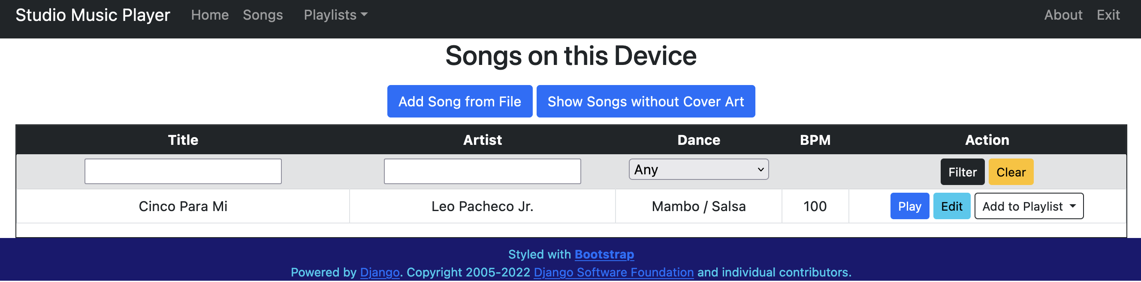

Figure 21 – View filtered to show modified song

Most audio files do not include the Tempo/BPM information in the metadata. For songs without BPM values, the SMP application displays N/A or -1.

There are two ways to obtain BPM information.

* The BPM values can be looked up on [songbpm.com](https://songbpm.com/) and entered manually.
* If the user has a Spotify account, the BPM values can be extracted automatically by clicking the Lookup BPM on Spotify button.

When looking up a BPM value on Spotify, the user may progress through several screens. First, they will be instructed to click the Sign in to Spotify button, as shown in Figure 22. See the Sign in to Spotify section for the steps to follow.

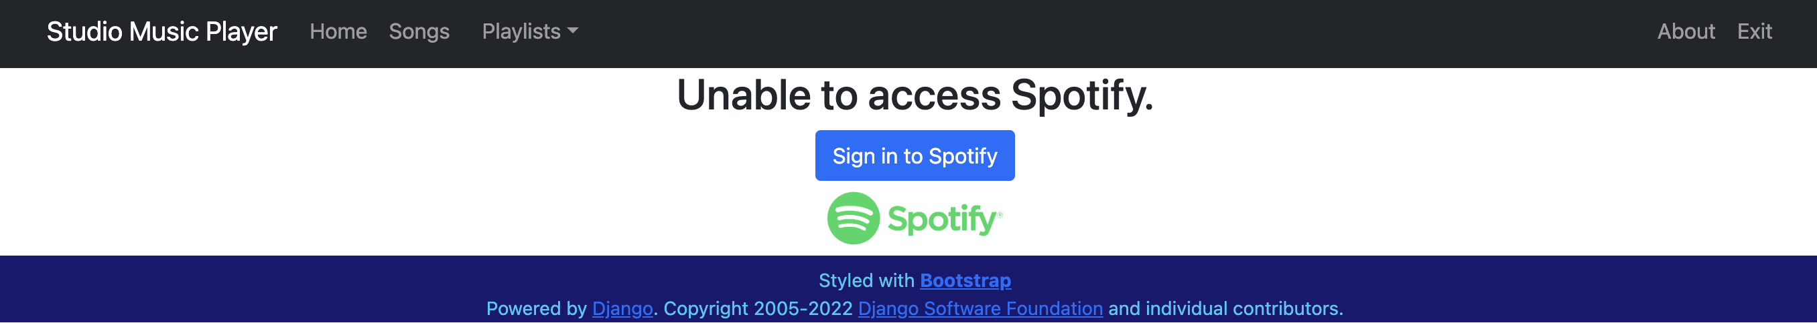

Figure 22 - Unable to access Spotify

Once the user is signed in, the Studio Music Player application will perform a Spotify search for a matching track. If a match is found, the BMP value will be extracted and the user will be returned to the Songs page, filtered to show the modified song as shown in Figure 23.

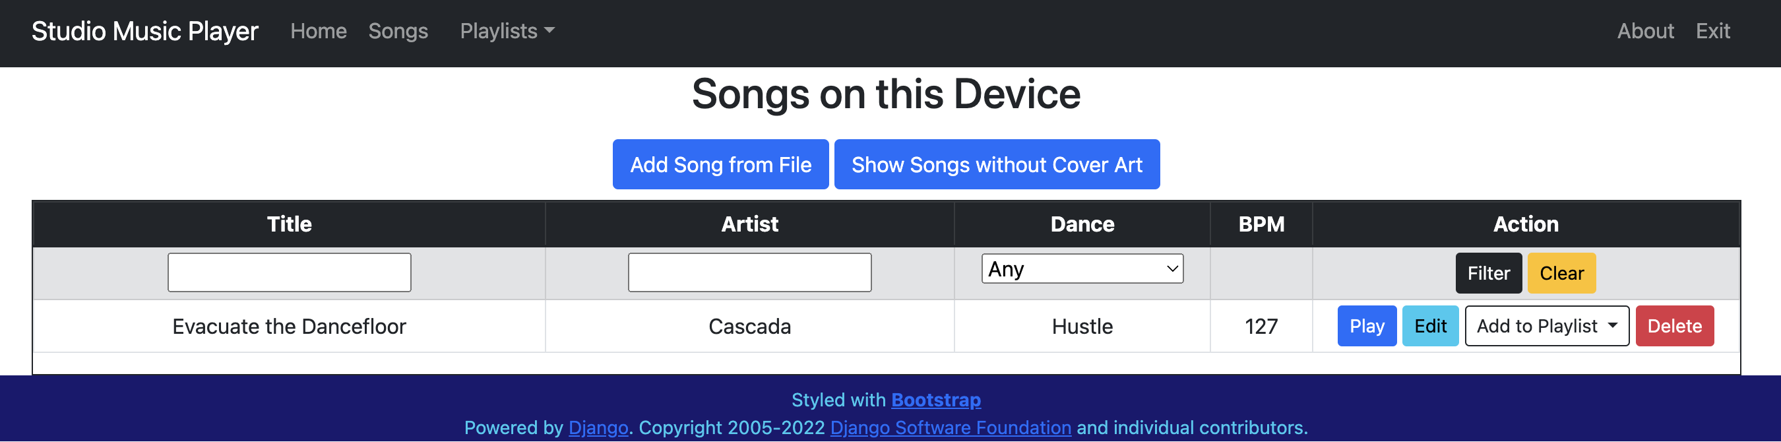

Figure 23 - BMP value extracted from Spotify

If a match is not found, a second search will be performed based only on the song title. A table of matching titles will be displayed, as shown in Figure 24. The user than selects a track from the list by clicking the Use BPM button.

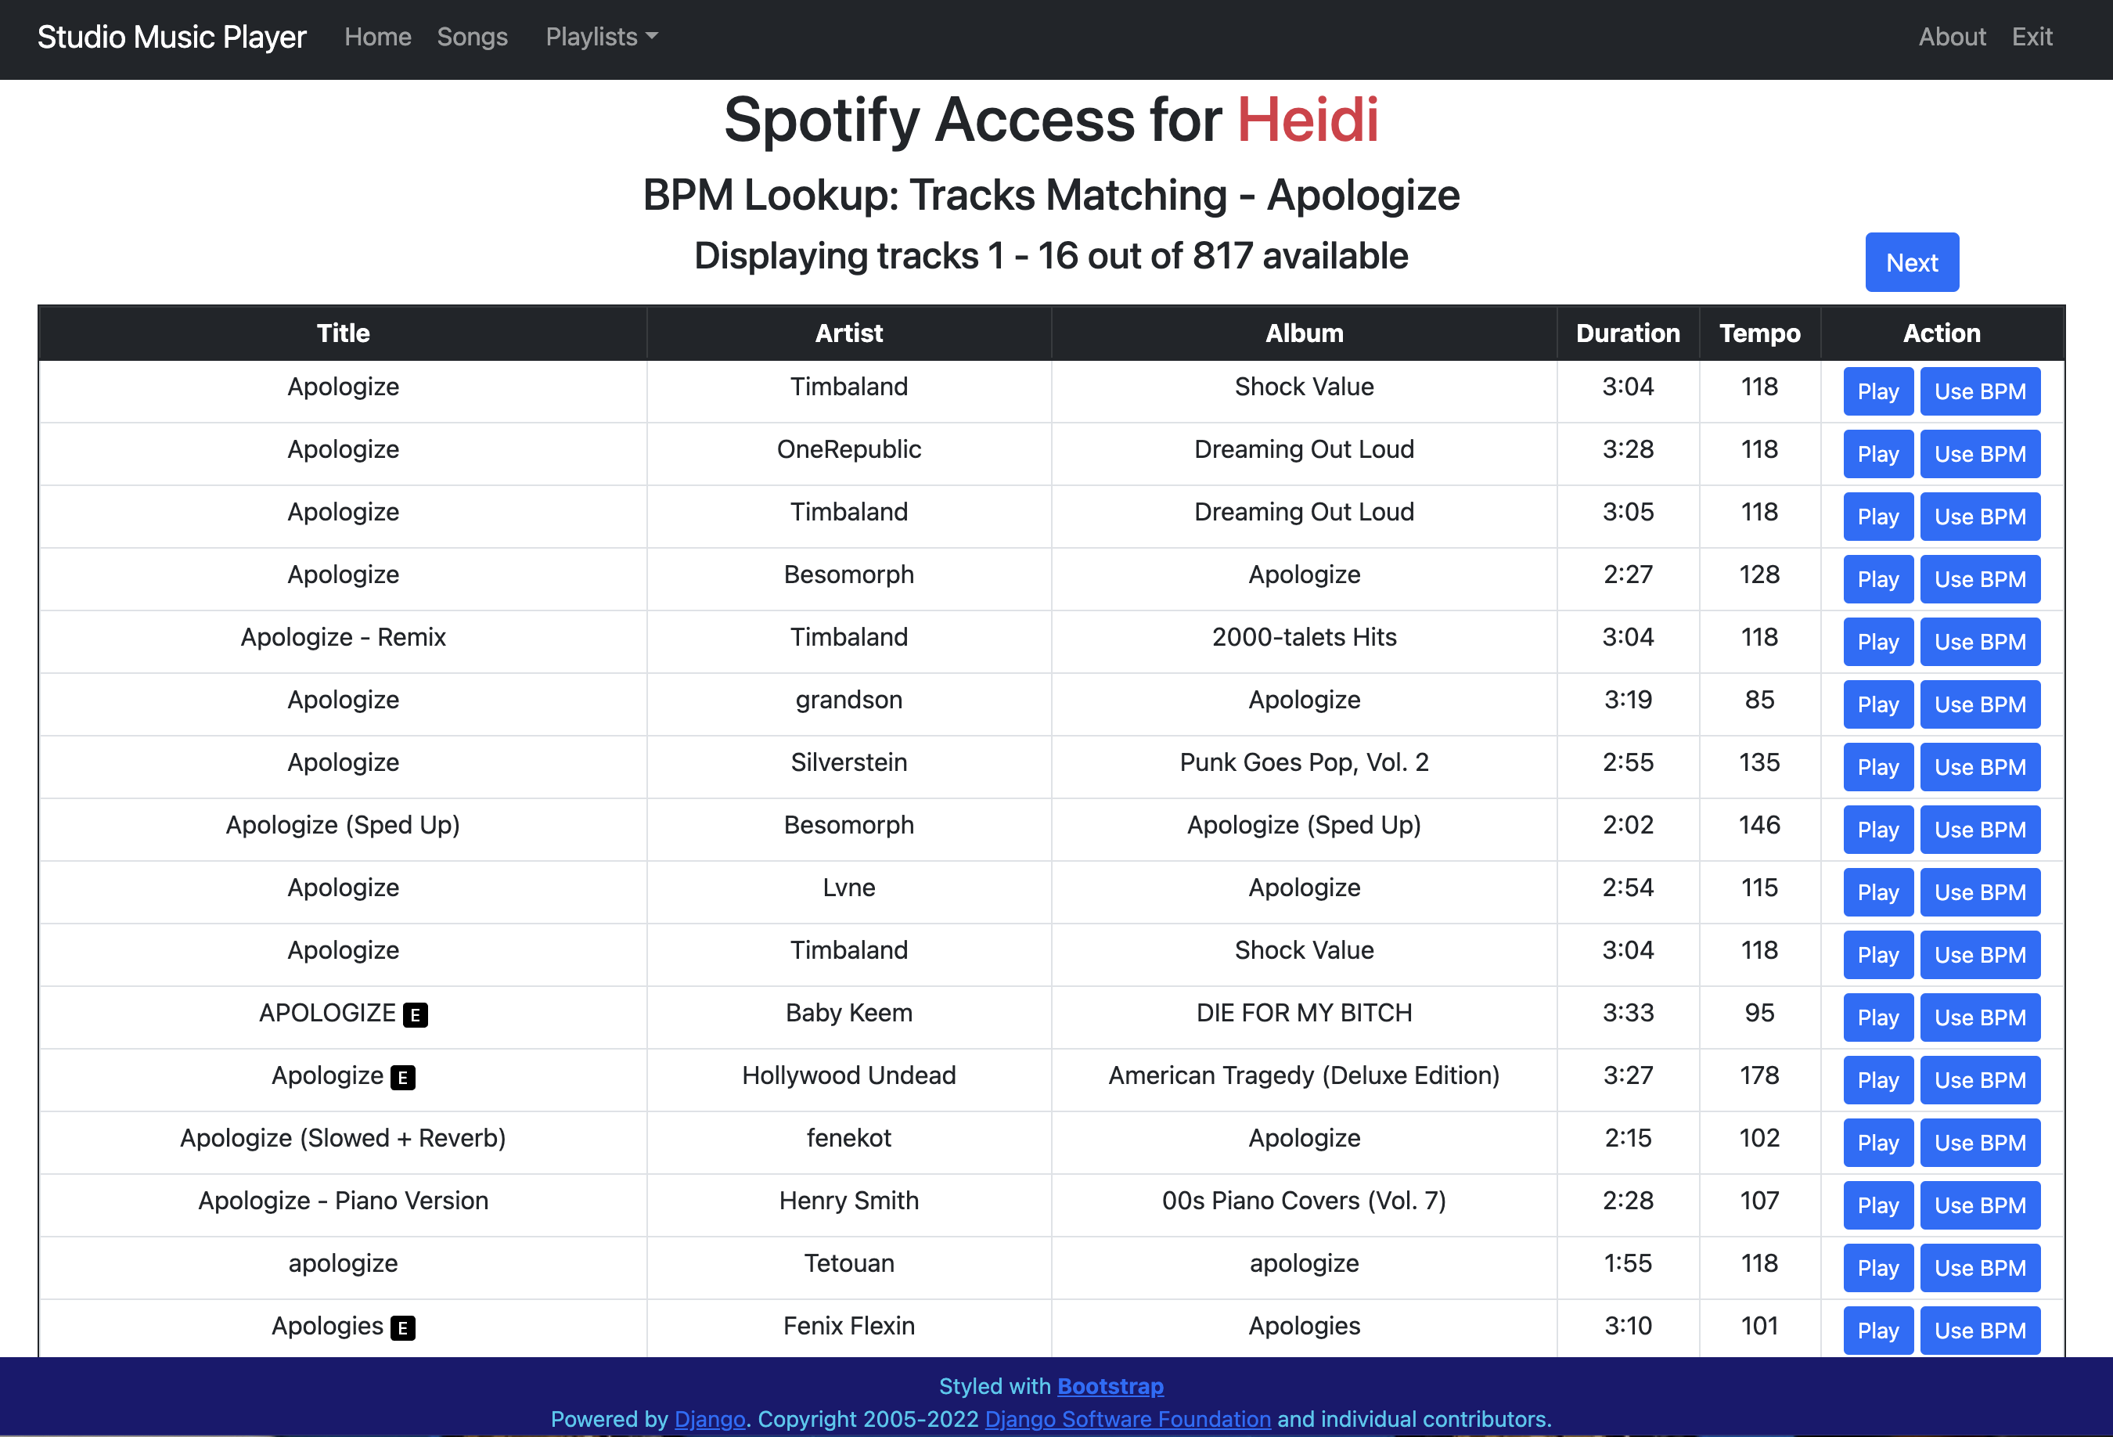

Figure 24 - Spotify tracks with matching titles

The user will be returned to the Songs page, filtered to show the modified song as shown in Figure 25.

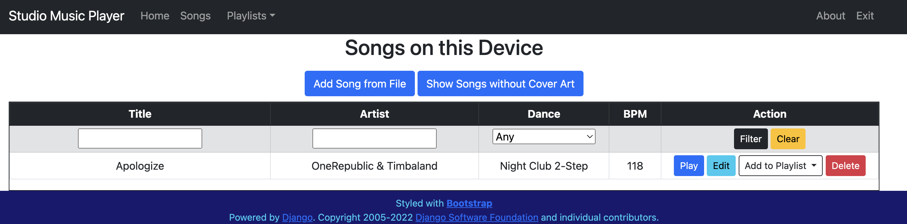

Figure 25 - BMP value extracted from selected track

## Playlists on this Device

As shown in Figure 26, the Navigation Bar contains a Playlist dropdown menu with three options.

* **Your Playlists –** displays a table of playlists created by the current user.
* **Your Playlist Preferences –** displays the default options selected by the current user for generating random playlists.
* **Your Playlists –** displays a table of all playlists in the SMP application created by any user.

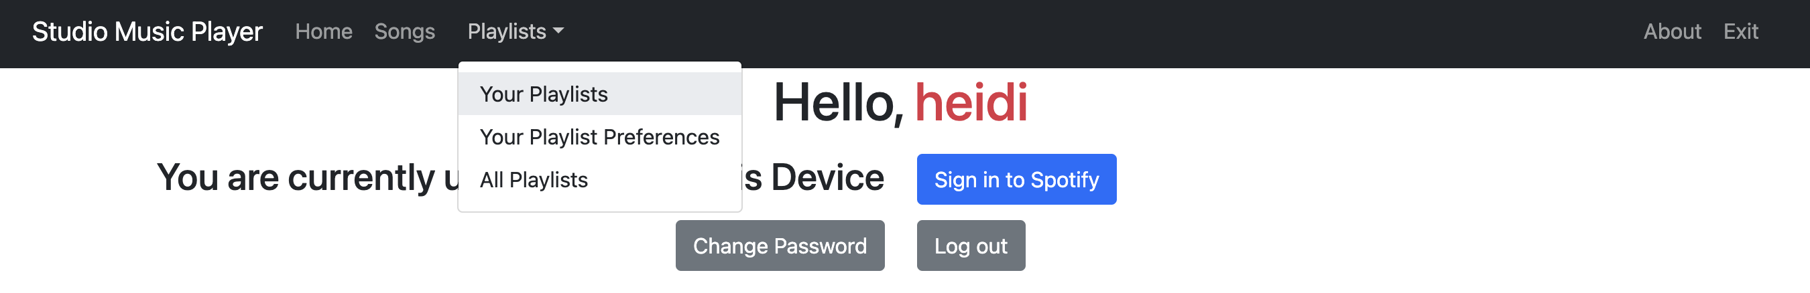

Figure 26 - Playlist dropdown menu

### Playlist Categories

The Studio Music Player supports three playlist categories.

1. **Normal** – the entire song is played, and the next song starts automatically.
2. **Party** – each song is played and faded out at a selected time limit (between 1:15 and 3:00) and the next song starts automatically.
3. **Showcase** – each song is faded out at a selected time limit (between 1:15 and 3:00) and the playback is paused between songs.

### Your Playlists

This page displays a table of all playlists created by the current user, as shown in Figure 27. For each playlist, the Title, Owner (user), Category, Song Time Limit (if applicable) and a Description are displayed.

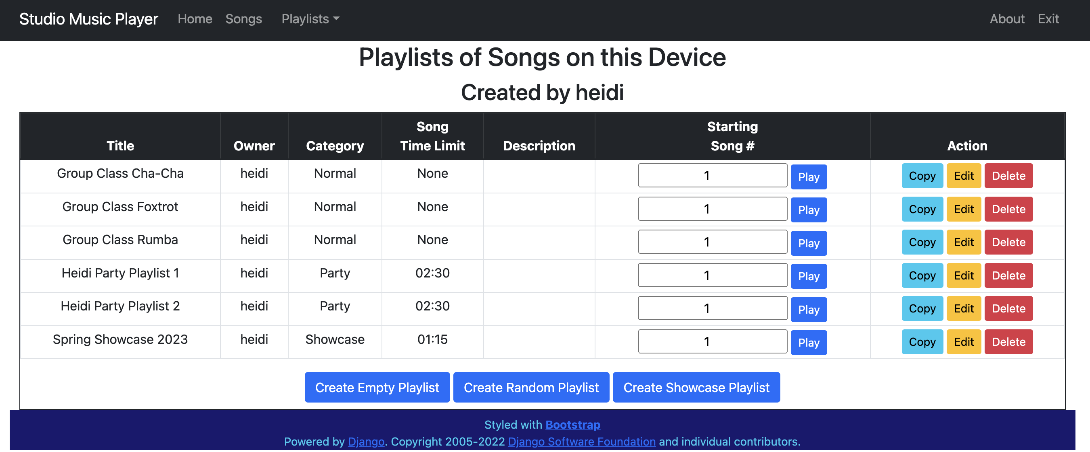

Figure 27 - Table of Playlists owned by the current user

From this page, the user can create new playlists by clicking any of these buttons:

* **Create Empty Playlist** – creates a new playlist with no songs
* **Create Random Playlist** – creates a playlist with randomly selected songs from the database
* **Create Showcase Playlist** – reads in a showcase program file and creates a playlist of placeholder songs with the specified dance type for each heat

The user can also perform the following actions on any of the playlists in the table:

* **Play** the playlist, starting at a specific song number (default is 1).
* **Copy** the playlist to another name.
* **Edit** the playlist in a variety of ways.
* **Delete** the playlist from the application. Note that the Songs in the playlist are not deleted during this process.

### Create an Empty Playlist

When the user clicks the Create Empty Playlist button, the page in Figure 28 is displayed.

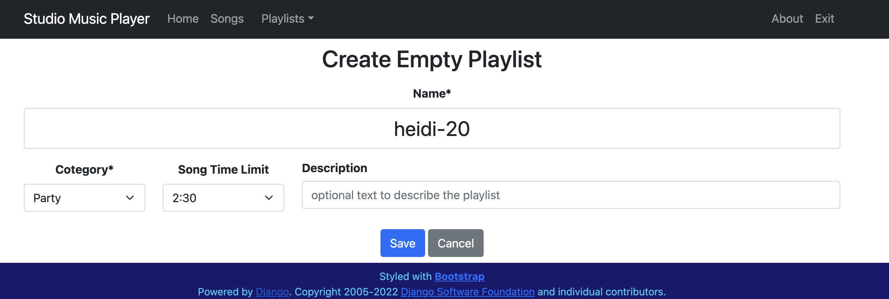

Figure 28 - Create Empty Playlist Form

The following fields on the form can all be edited:

* **Name** – A default name is generated as the title of the playlist. The user can replace this with another name, as shown in Figure 29. Note that the new name must not be the same as an existing playlist.
* **Category** – Select Normal, Party, or Showcase via the pulldown menu.
* **Song Time Limit** – Set the Time Limit via the pulldown menu as shown in Figure 29. A time limit must be set for Party and Showcase playlists.
* **Description** – In addition to the playlist name, the user can enter text into this field to further describe the playlist. This field is optional.

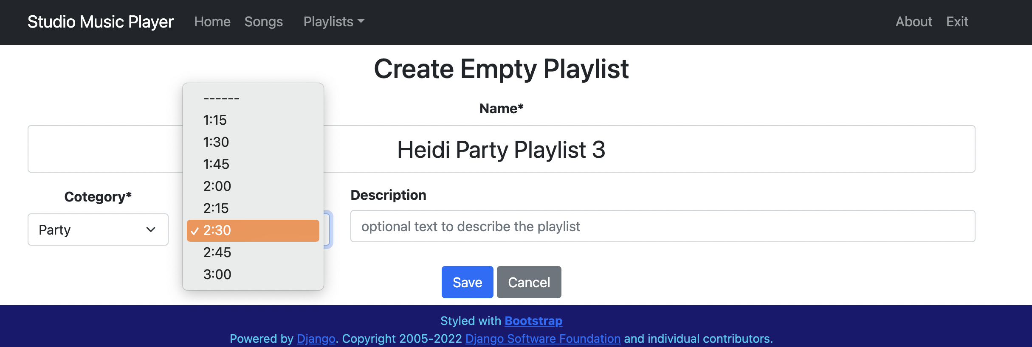

Figure 29 – Changing playlist information

Once all fields have been set, click the Save button to create the playlist. The user is returned to the User Playlists screen.

### Create a Random Playlist

When the user clicks the Create Random Playlist button, the page in Figure 30 is displayed. This page has the same fields as the Create Empty Playlist page, but the Save button has been replaced by the Continue button.

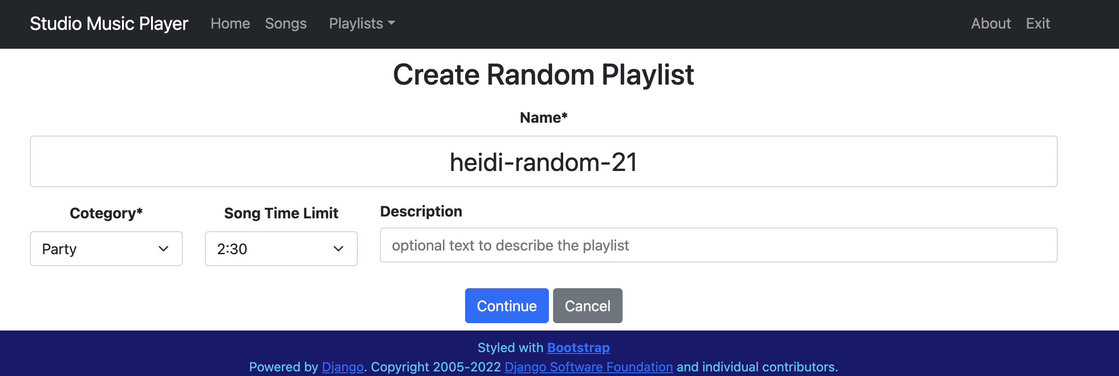

Figure 30 - Create Random Playlist part 1

If the user sets the name to Heidi Party Playlist 4 and clicks the Continue button, the page in Figure 31 is generated based on the user’s playlist preferences.

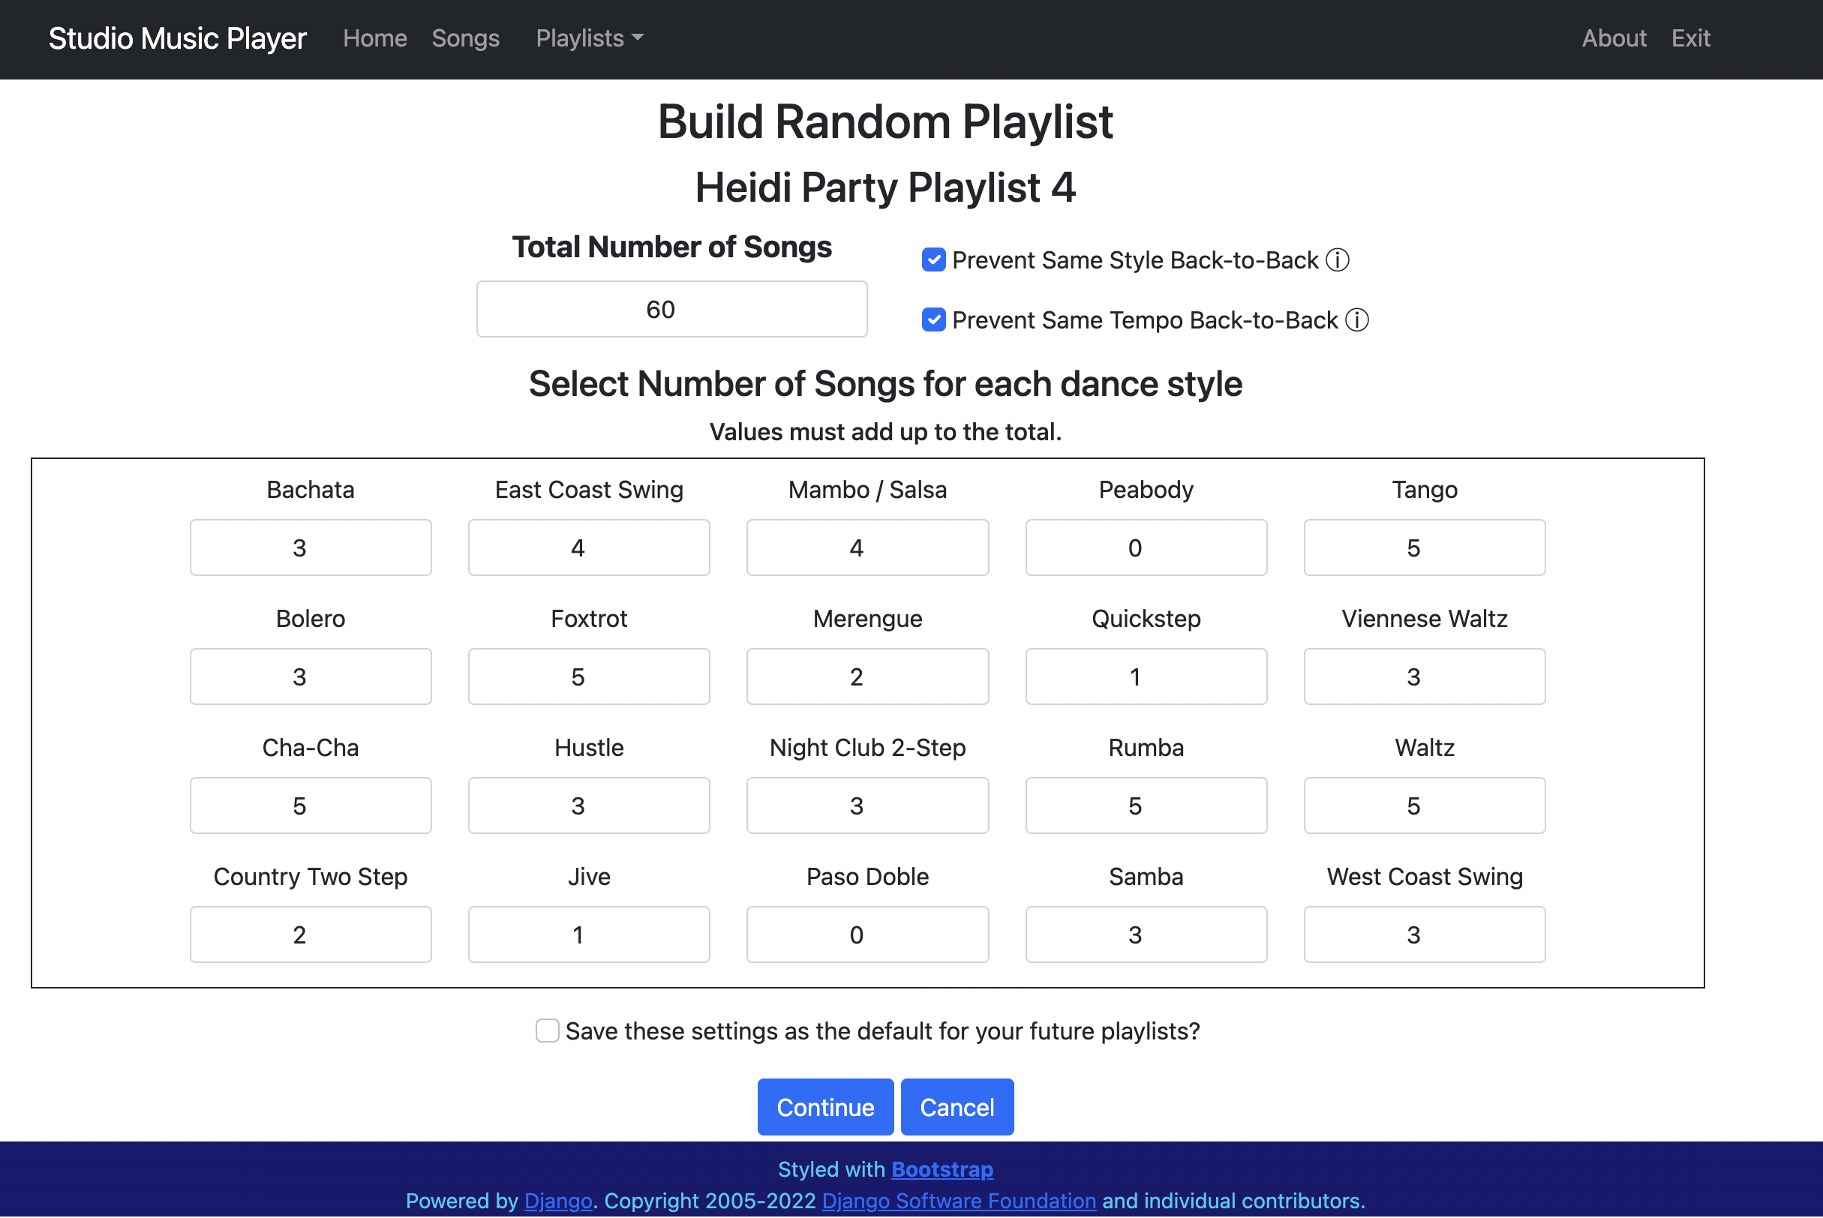

Figure 31 – Create Random Playlist part 2

When generating random playlists, the user may change the number of songs for each dance style, but they must add up to the Total Number of Songs. If there is a mismatch, a red error message is displayed and the Continue button is disabled, as shown in Figure 32.

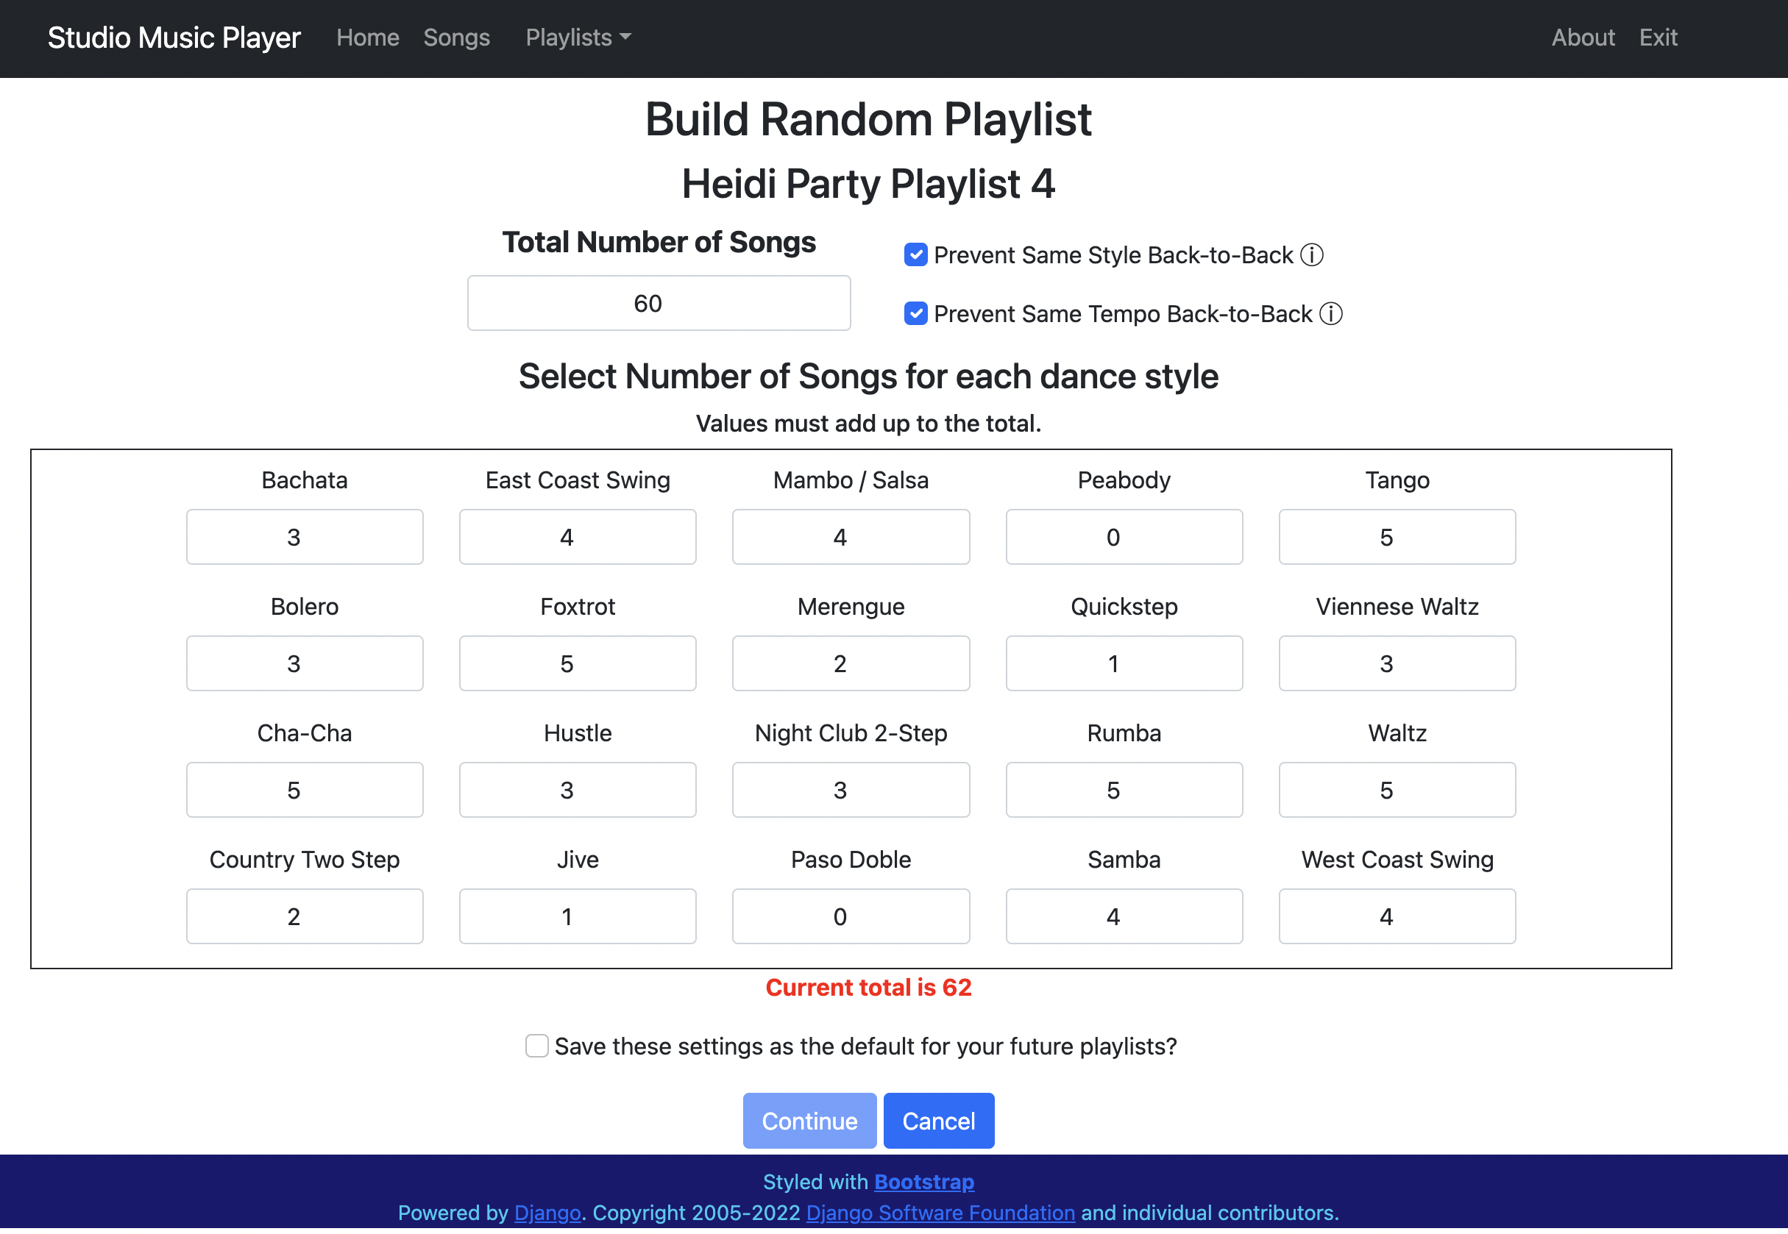

Figure 32 - Incorrect number of songs

When these checkboxes are selected, the playlist generation is affected as follows:

* Prevent Same Style Back-to-Back – this option prevents two consecutive songs of the same style (e.g. Waltz) from appearing in the playlist.
* Prevent Same Tempo Back-to-Back –this option prevents two consecutive “fast” dance styles or two consecutive “slow” dance styles from appearing in the playlist.
  + East Coast Swing, Hustle, Jive, Mambo/Salsa, Peabody, and Quickstep are considered “fast” dance styles.
  + Bolero, Night Club 2 Step, Rumba, and Waltz are considered “slow” dance styles
* Save these settings as default for future playlists – when checked, this set of selections will be saved as the starting point for future random playlists.

Once the Continue button is clicked, the user is redirected to the Edit Playlist page to see the songs that were randomly selected.

### Create a Showcase Playlist

This selection reads a file which has a list of heats and dance styles for an upcoming competition or showcase. A playlist is generated with placeholder songs with the correct dance style in the order based on the file contents.

More details will be added in the future.

### Copying a Playlist

If the user clicks on a Copy button in the table of playlists, a new playlist is created with the exact same songs as the original playlist.

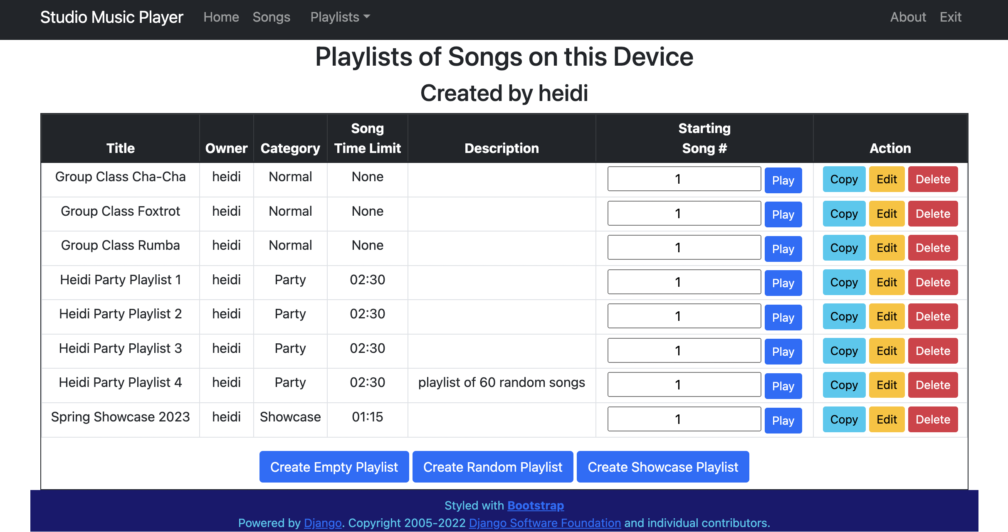

Figure 33 - User Playlists prior to copying

For example, if the user clicks the Copy button in the Heidi Party Playlist 2 row of the table in Figure 33, a new playlist named copy-Heidi Party Playlist 2 appears in the table, as shown in Figure 34. This new playlist can be edited as desired.

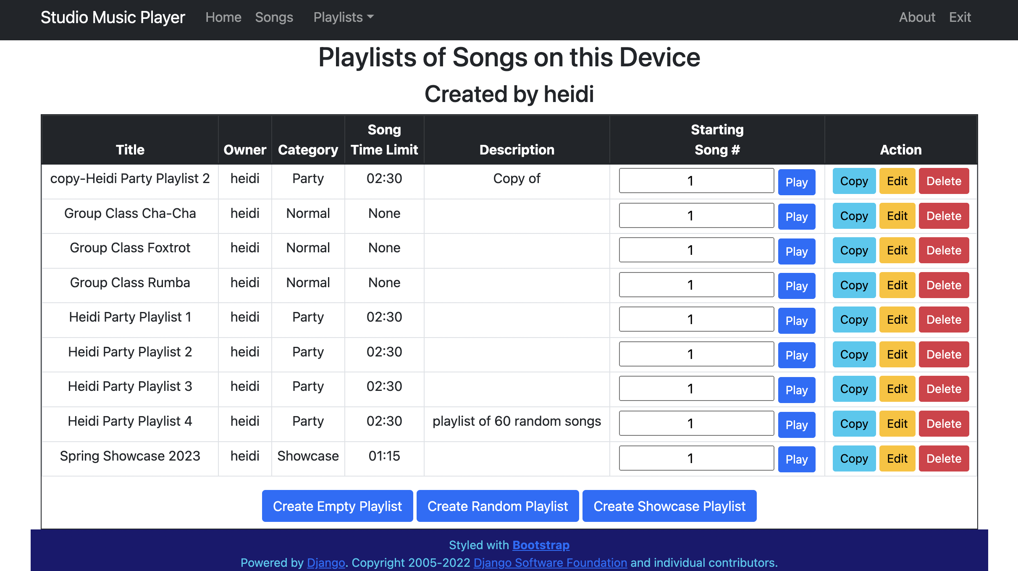

Figure 34 - User playlist after copying

### Editing a Playlist

If the user clicks on an Edit button in the table of playlists, the Edit Playlist page is displayed. Recall that in the Create an empty playlist section, Heidi Party Playlist 3 was created. If the user clicks the Edit button in the Heidi Party Playlist 3 row of the table in Figure 33, the page in Figure 35 is displayed.

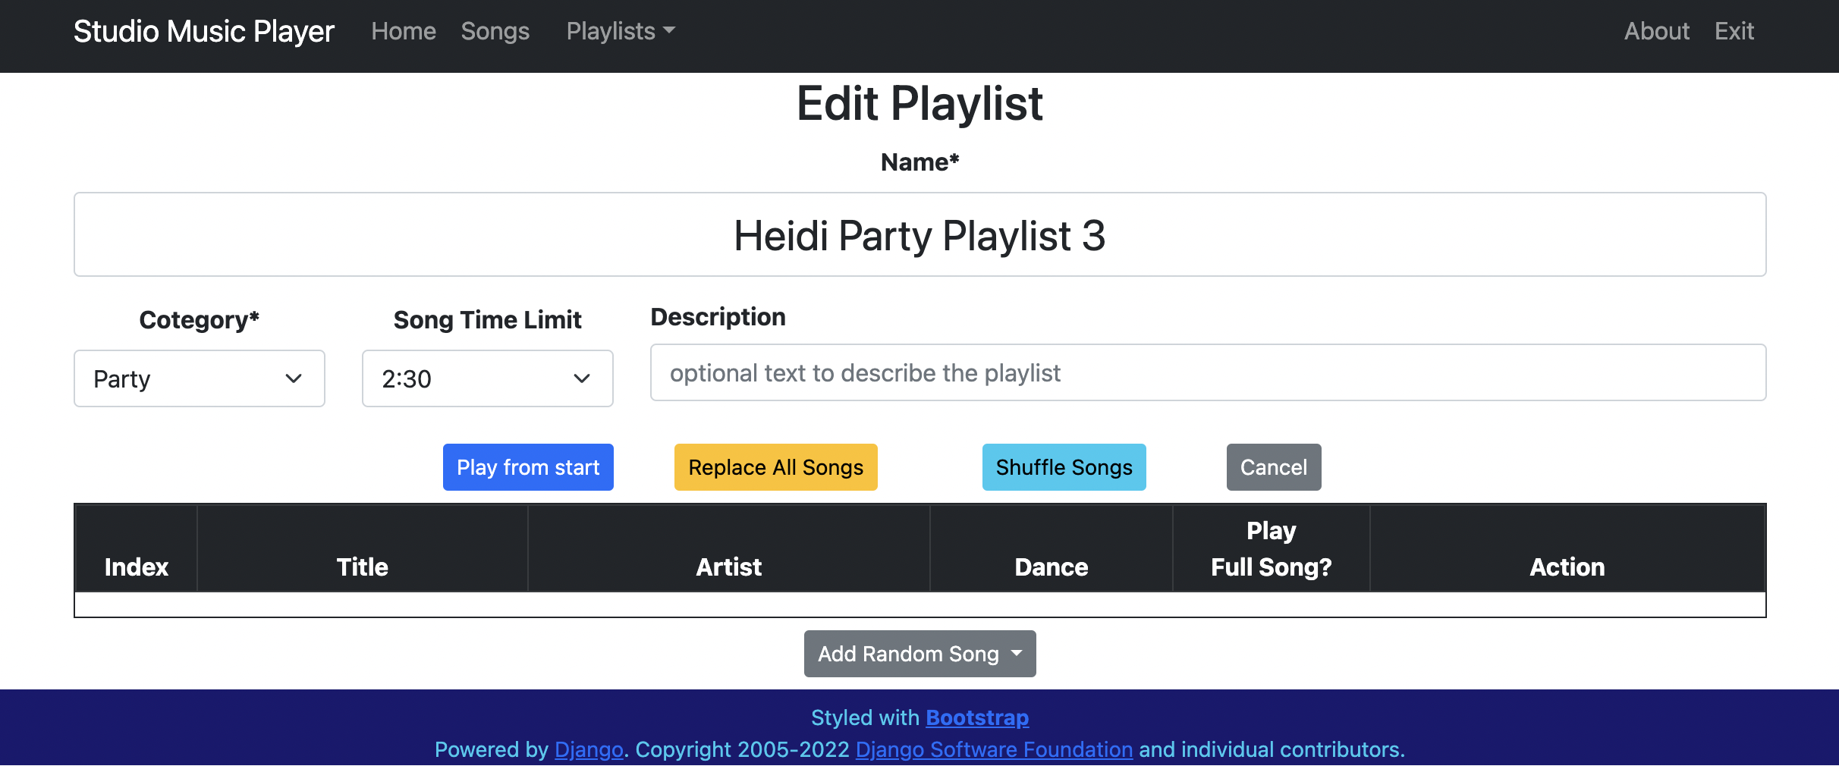

Figure 35 - Editing an empty playlist

The user may modify the Name, Category, Song Time Limit, and Description fields in the same way as when the playlist was created. Each change to these fields is immediately saved.

### Adding Random Songs to a Playlist

Below the table of songs of every playlist is an Add Random Song pulldown menu. As shown in Figure 36, this menu allows the user to select a dance style and a random song of that dance style will be added to the end of the playlist, as shown in Figure 37.

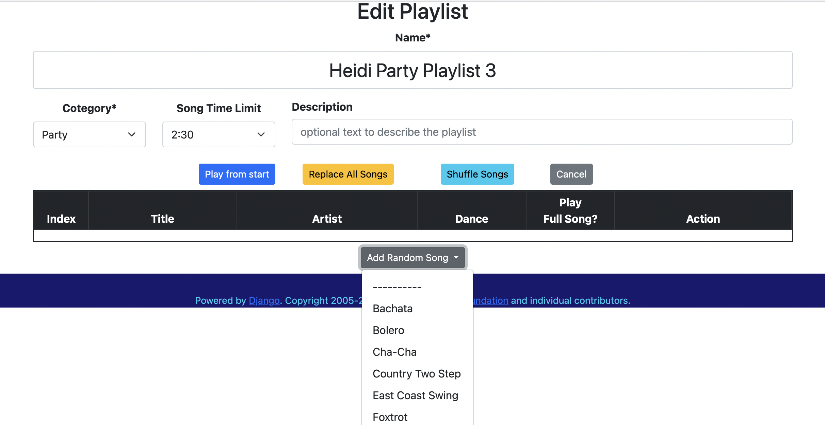

Figure 36 – Add Random Song pulldown menu

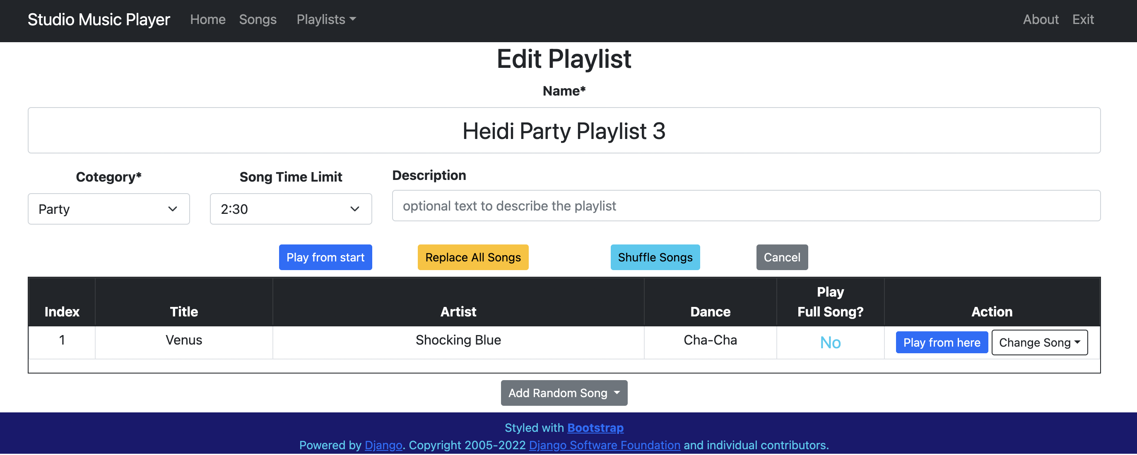

Figure 37 - Random song added to playlist

### Adding a Selected Song to a Playlist

The user can also use the Songs page to add a specific song to the end of a playlist. As shown in Figure 38, clicking the Add to Playlist button reveals a list of playlists owned by the user.

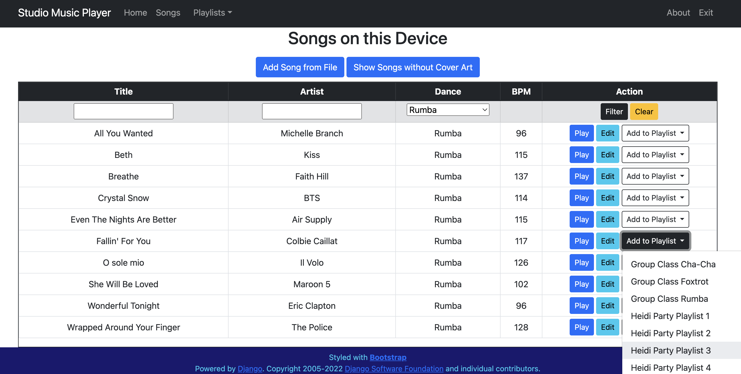

Figure 38 - Adding a song to playlist

Once the user selects a playlist from the pulldown menu, the song is added to that playlist and the user is redirected to the Edit Playlist menu as shown in Figure 39. The row containing the new song is highlighted to draw attention to the change.

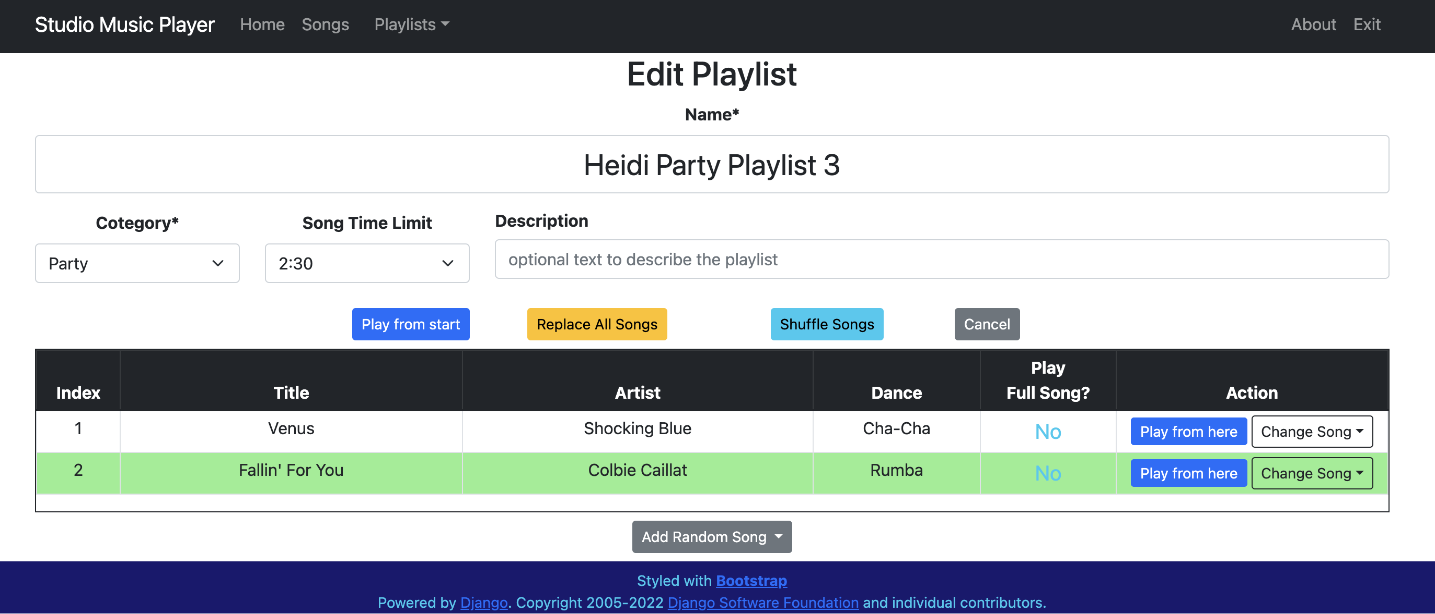

Figure 39 – Selected song added to playlist

### Random Replacement of a Playlist Song

As shown in Figure 40, each song in a playlist has a Change Song pulldown menu.

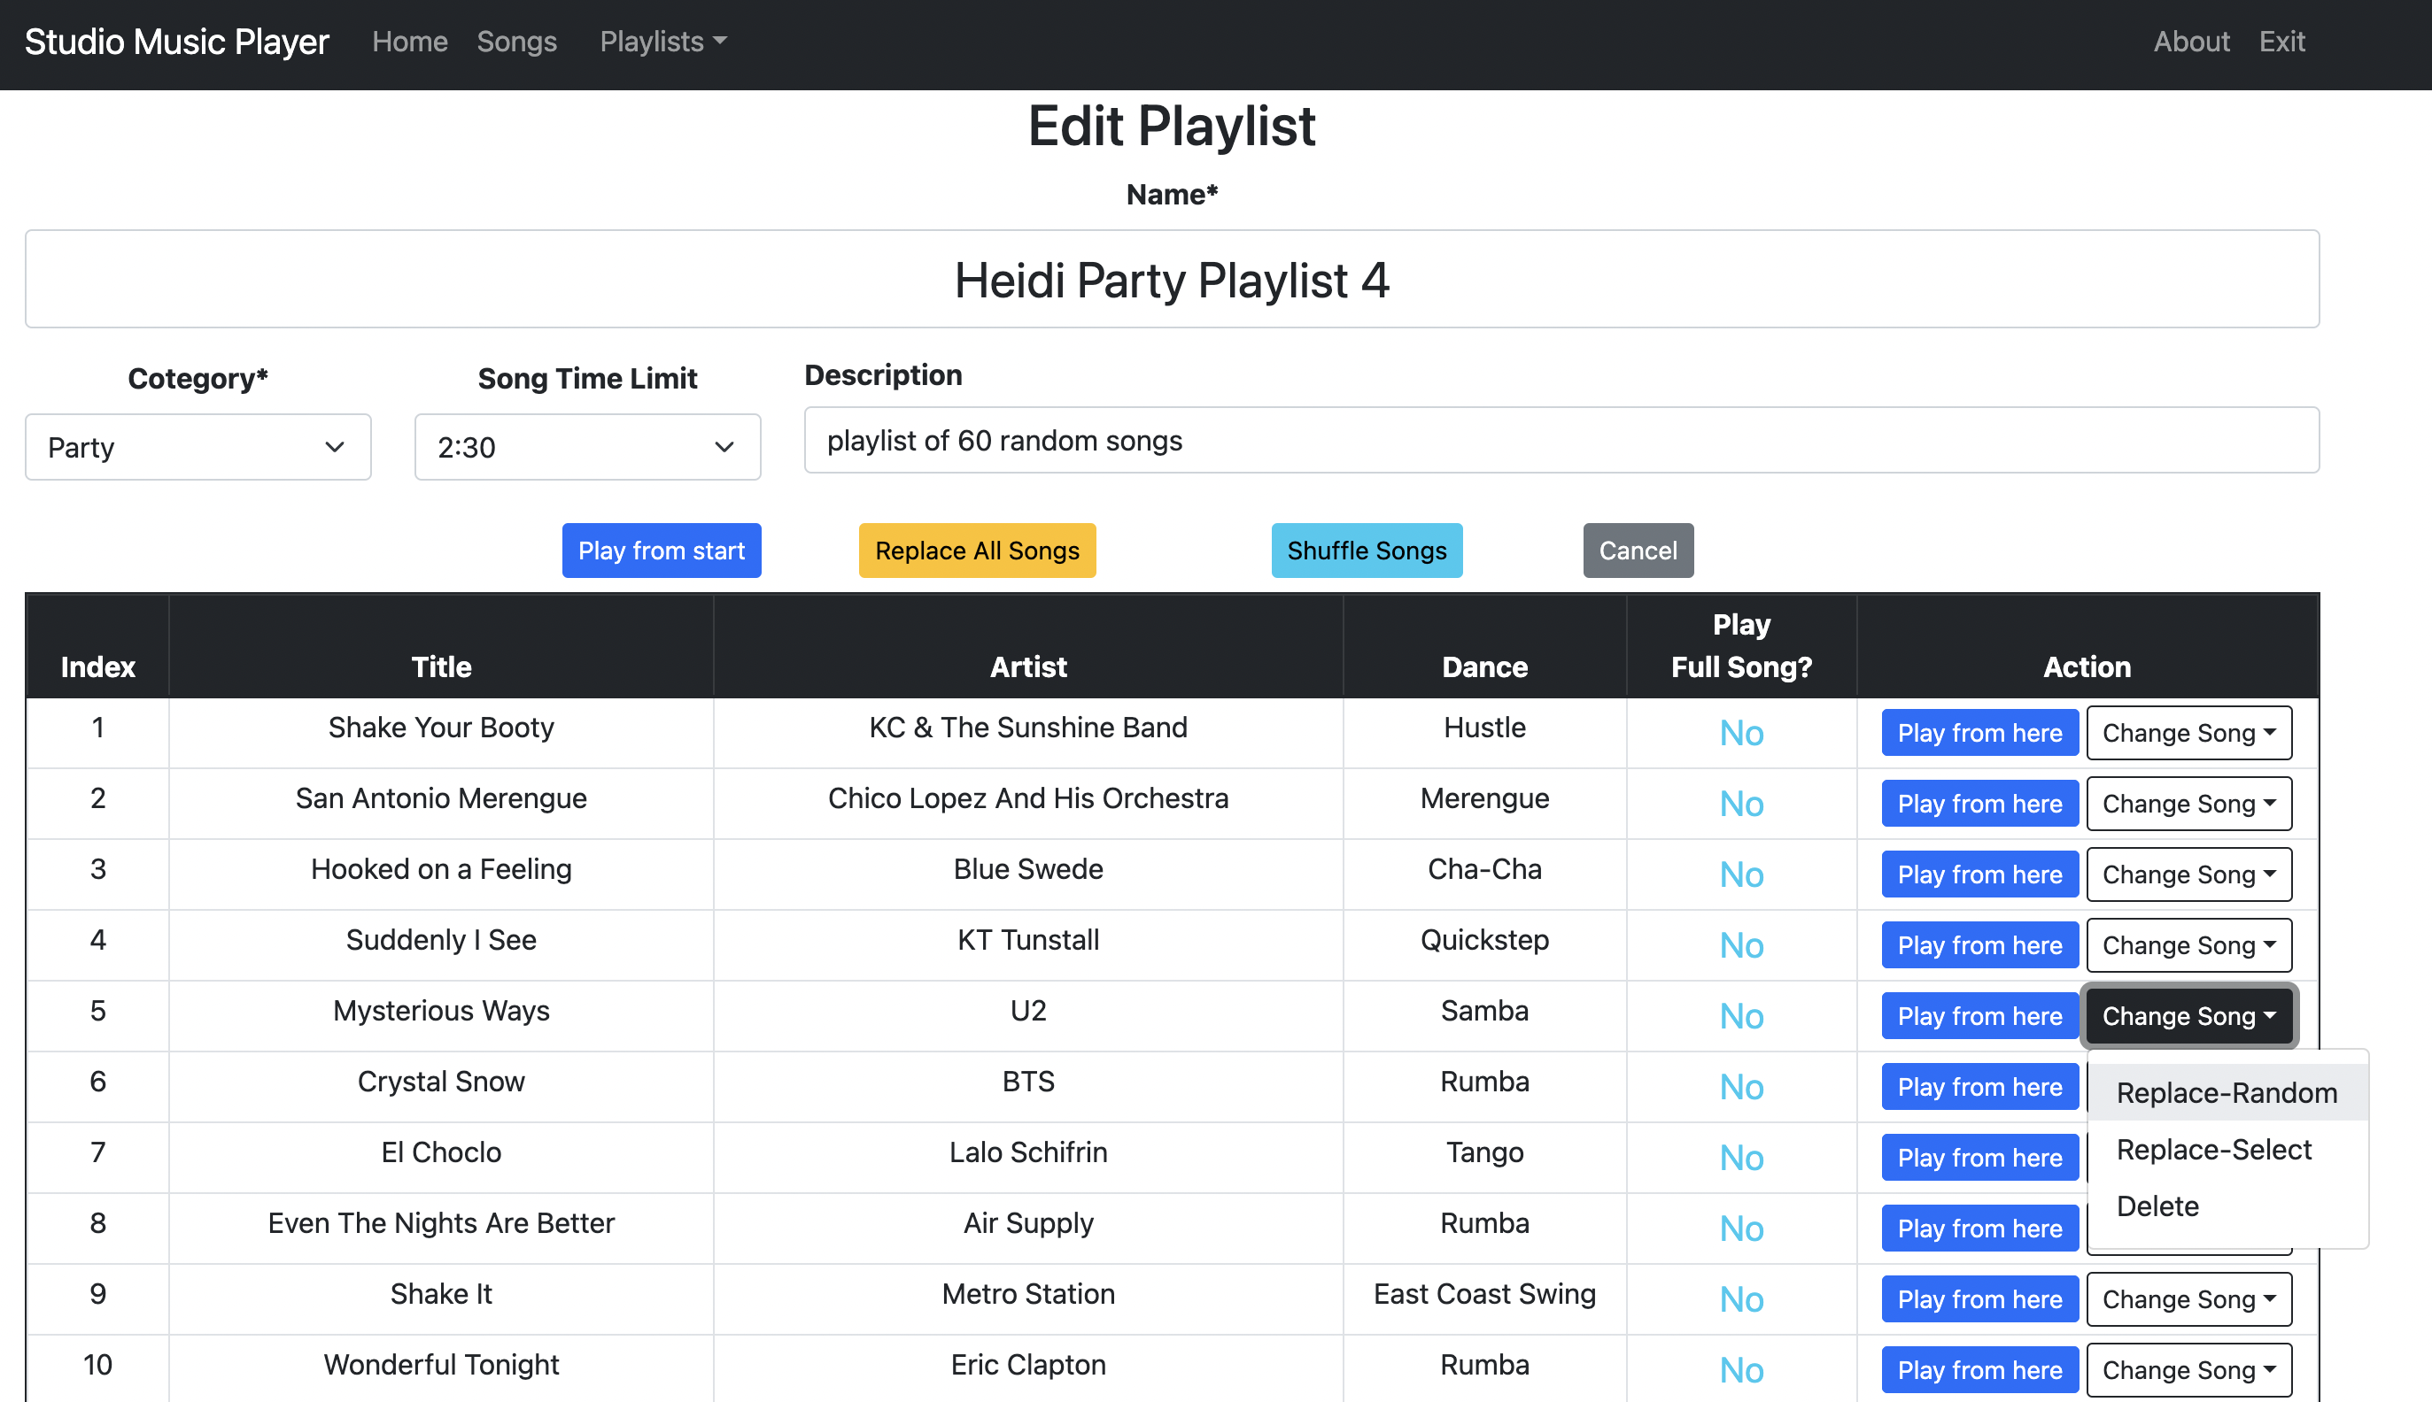

Figure 40 - Change Song pulldown menu

Selecting the Replace-Random option allows the user to replace the selected song with a random song of the same dance style. As shown in Figure 41, the new random song is highlighted to indicate the change.

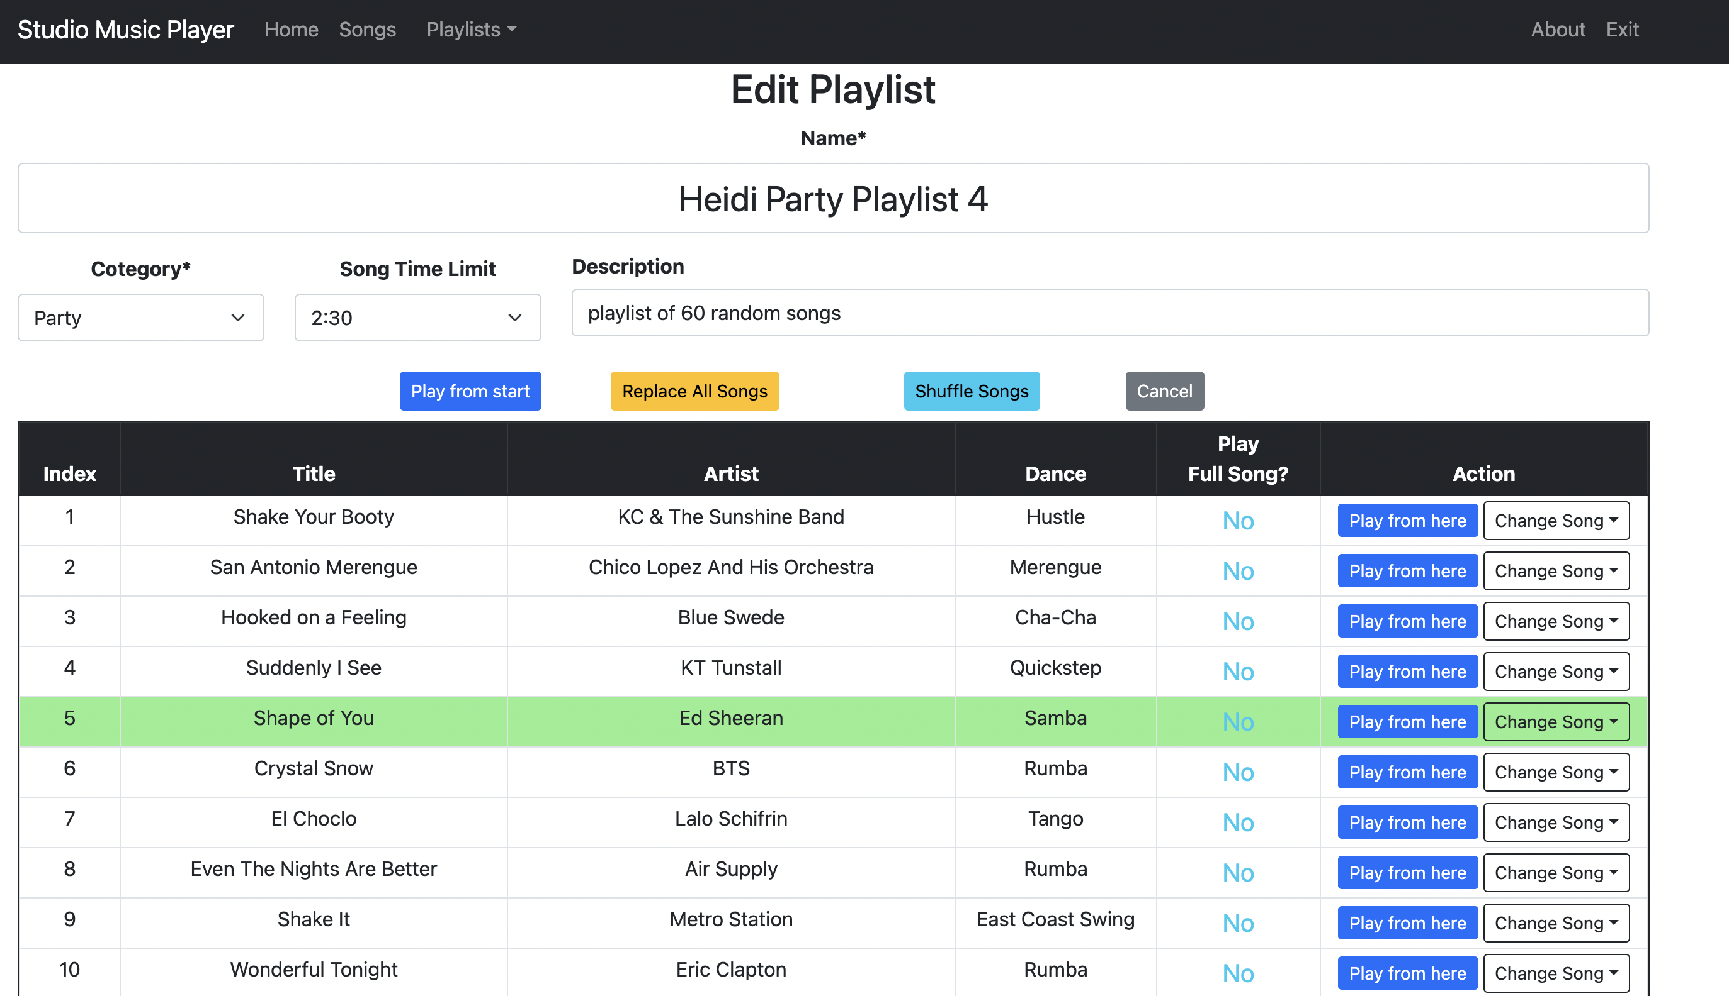

Figure 41 - Replace playlist entry with random song

### Selected Replacement of a Playlist Song

Selecting the Replace-Select option in the Change Song pulldown menu allows the user to select a song of the same dance style to replace the current song.

For example, the third song in Figure 41 is a Cha-Cha (*Hooked on a Feeling*). If the user chooses the Replace-Select option in this row, they will be presented with a list of Cha-Cha songs, as shown in Figure 42.

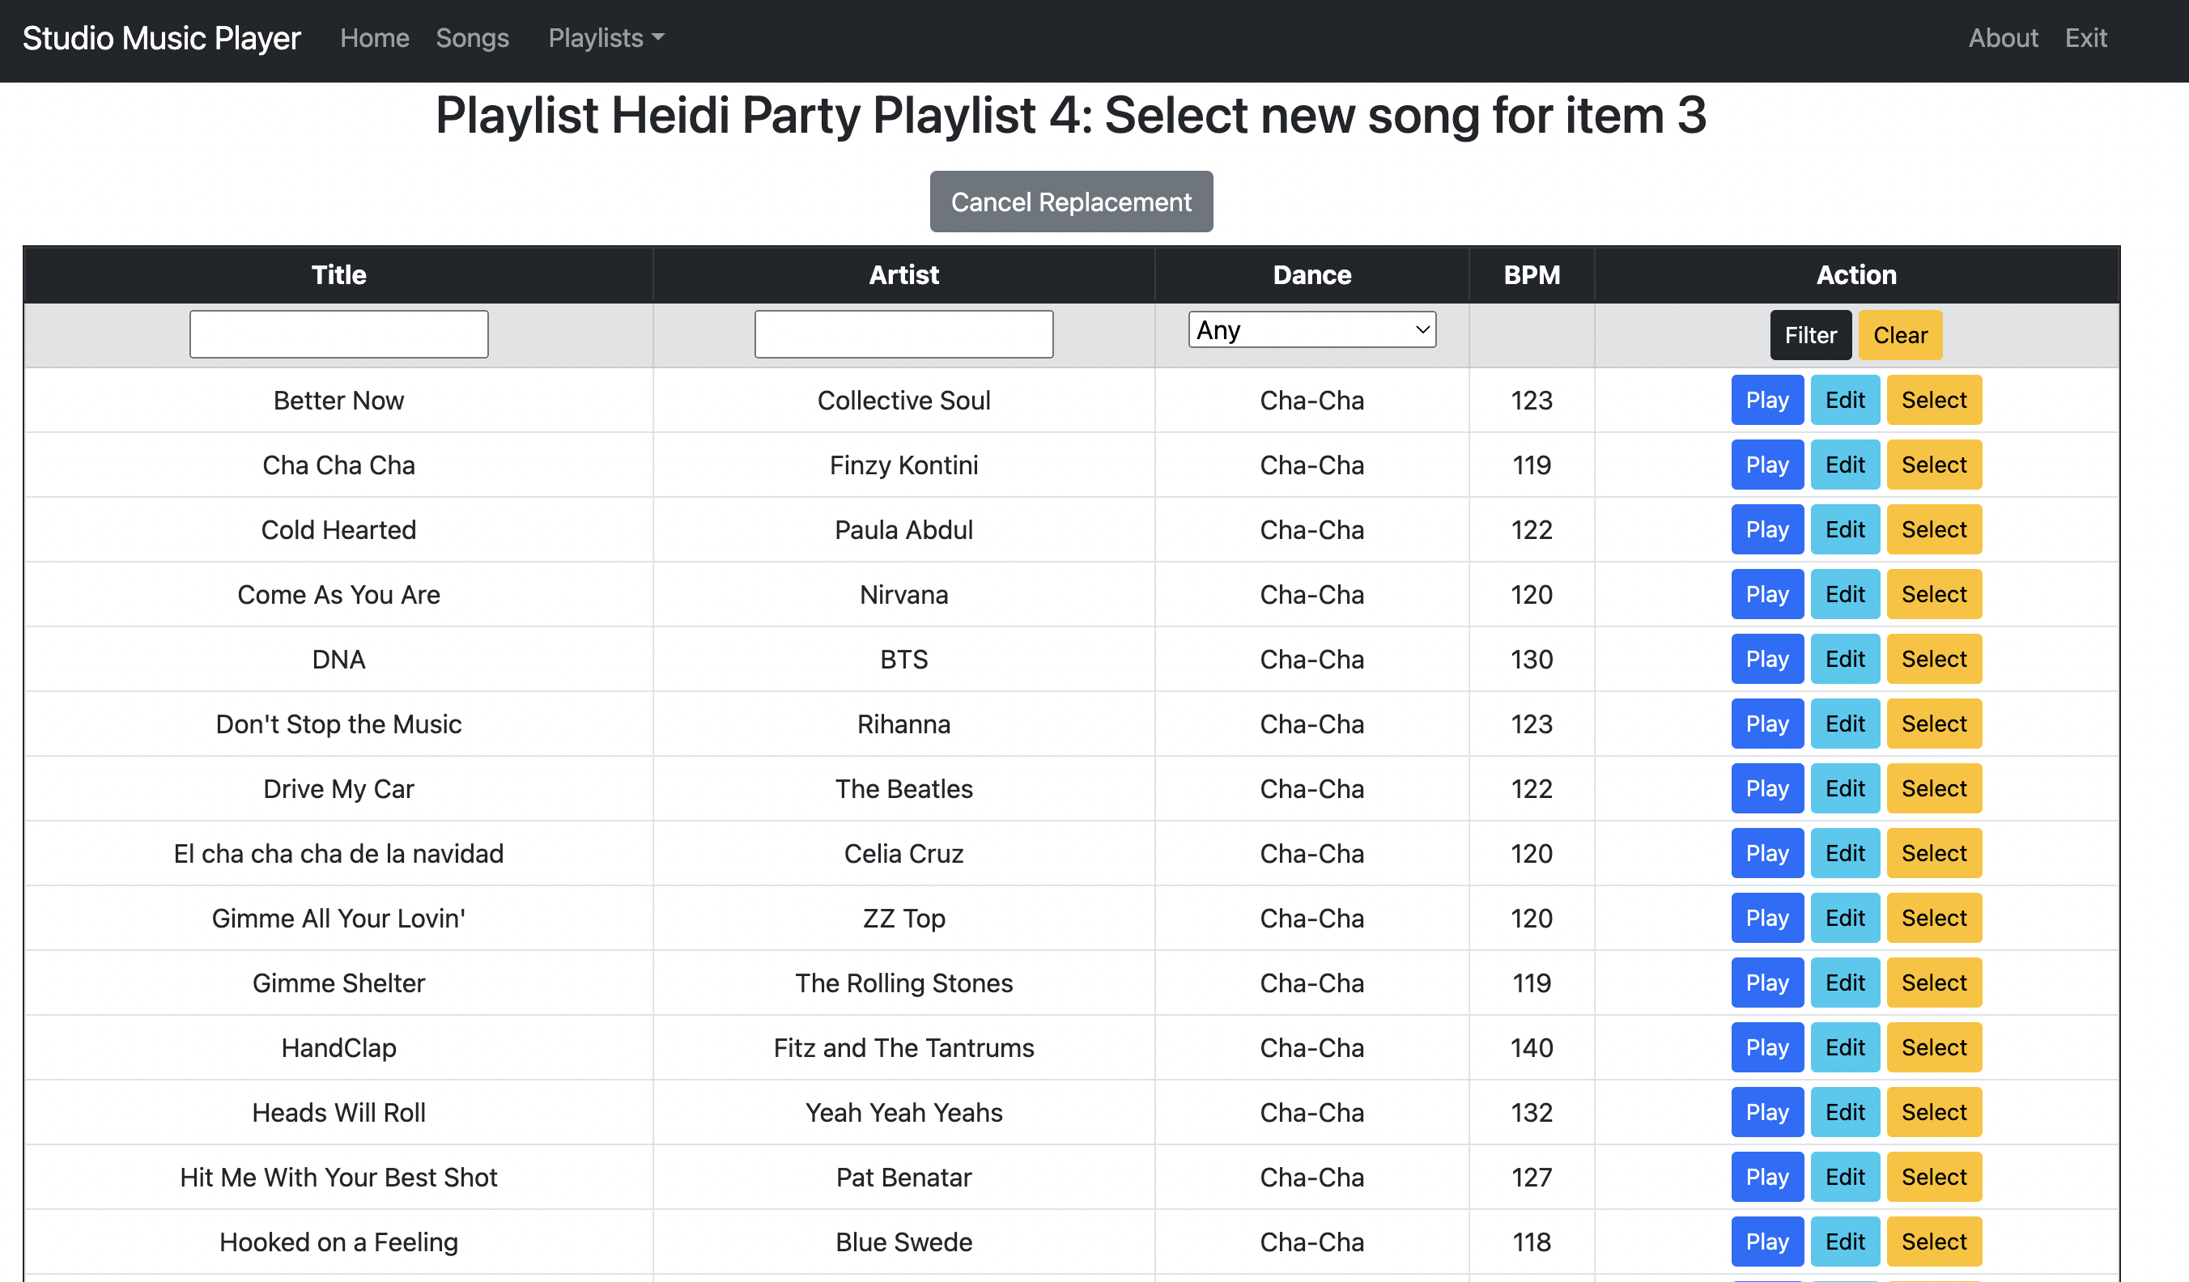

Figure 42 - Selecting a replacement song

This version of the Songs page has a Select button in each row. Clicking that button will select the song in that row (for example, *Gimme All Your Lovin’* by ZZ Top) as the replacement for *Hooked on a Feeling* in Heidi Party Playlist 4. See Figure 43.

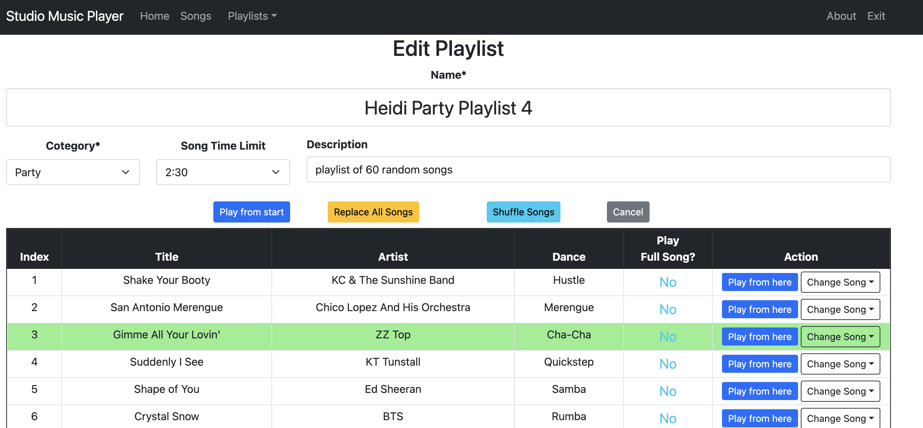

Figure 43 - Replace playlist entry with selected song

### Deleting a Song from a Playlist

Selecting the Delete option in the Change Song pulldown menu allows the user to remove the current song from the playlist. Note that the song is not removed from the Songs database and is not removed from any other playlist.

For example, the second song in Figure 43 is a Merengue (*San Antonio Merengue*). If the user chooses the Delete option in this row, they are asked to confirm their choice as shown in Figure 44.

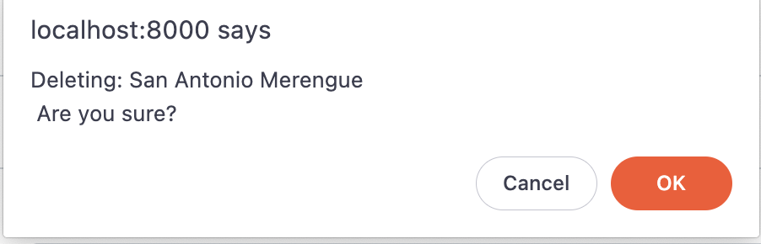

Figure 44 - Confirm intention to delete song

If the user clicks OK, the song is removed from the playlist as shown in Figure 45. Note that all other songs below the deleted song in playlist the move up in the order.

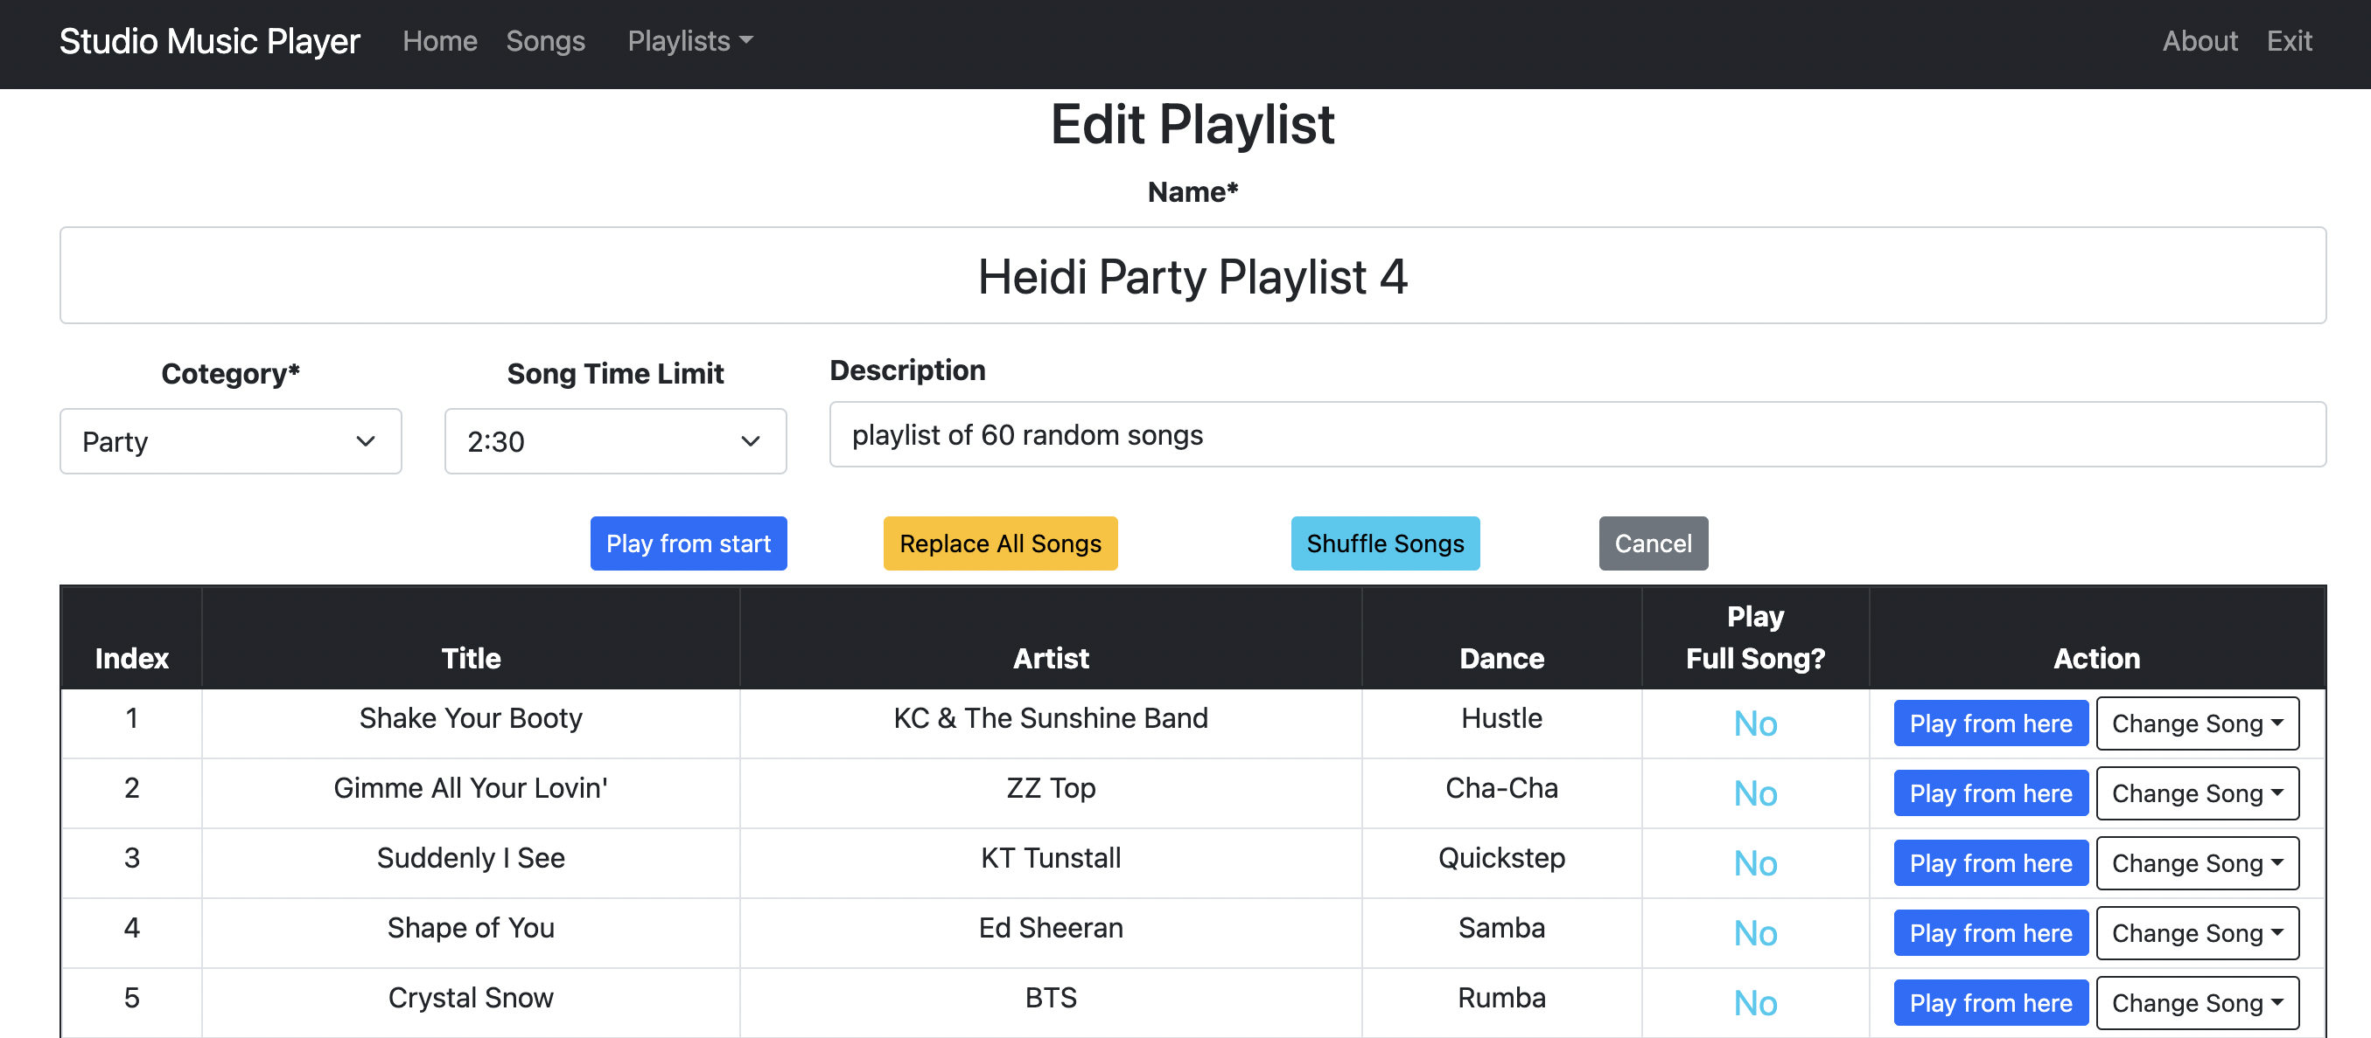

Figure 45 - Song deleted from Playlist

### Replacing All Songs in a Playlist

The Random Replacement of a Playlist Song section described how to replace a single song in the playlist with a random song of the same dance style.

The Replace All Songs button on the Edit Playlist page performs the same operation on every entry in the playlist. The dance style order of the playlist is maintained but every song in the playlist is replaced with a random song of the same dance style.

For example, if the user clicked on the Replace All Songs button in Figure 45, the results would look similar to Figure 46.

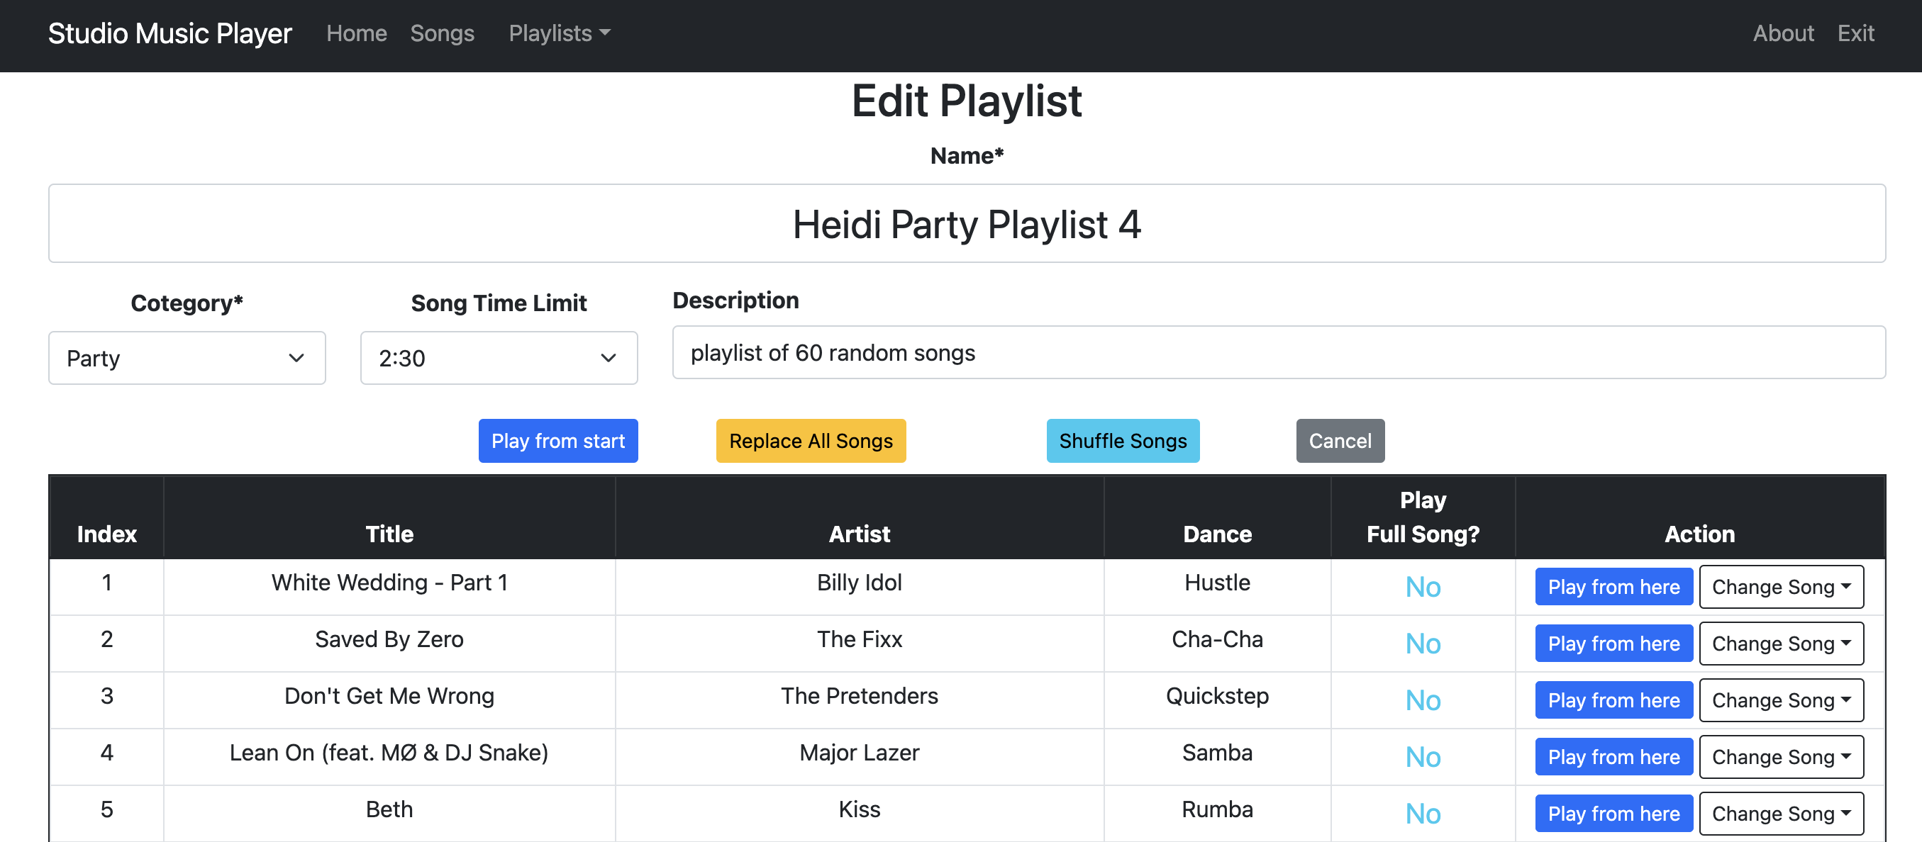

Figure 46 - Playlist after all songs replaced

### Shuffle a Playlist

The Shuffle Songs button on the Edit Playlist page keeps all the songs in the playlist and maintains the dance style order, but randomly changes the order of the songs.

For example, if the user clicked on the Shuffle Songs button in Figure 46, a Hustle song from somewhere else in the playlist would be moved to index 1, a Cha-Cha song from somewhere else in the playlist would be moved to index 2, and so on. If there are no other songs of the dance style in the playlist, such as the Quickstep in index 3, that song would stay in its original position. See Figure 47.

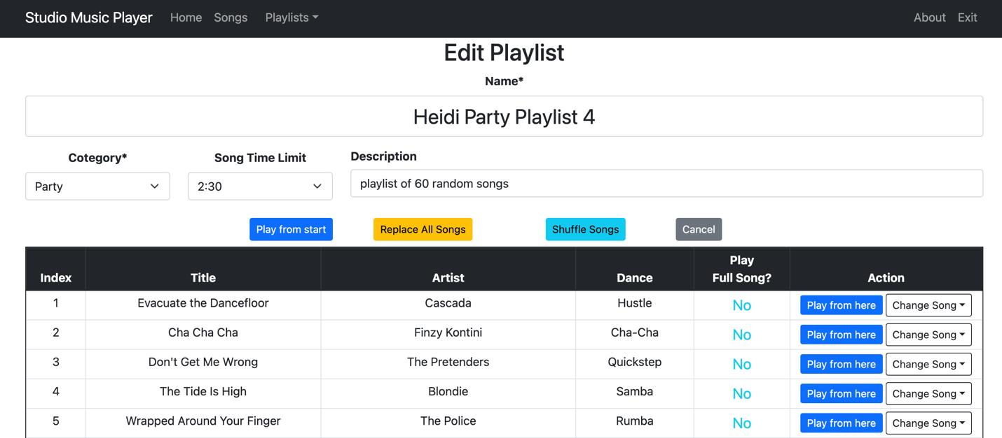

Figure 47 – Playlist after shuffling songs

### Move songs in a playlist with drag and drop

To change the order of the songs within a playlist, the user can perform the following steps:

1. Click on the song to move and hold down the mouse. The selected row in the table will be highlighted and a music note icon appears as shown in Figure 48.
2. While holding down the mouse, drag the music note icon toward the desired new index of the song within the playlist. While dragging the note icon, a blue horizontal line will appear to indicate the landing index. See Figure 49.
3. If the desired index of the song is not visible in the window, keep dragging the music note icon into the black table header section or the dark blue footer section. The table will scroll, making new songs of the playlist visible. Keep holding and scrolling until the desired index is visible.
4. To cancel the drag-and-drop operation, move the music note outside the left edge or right edge of the table. The music note will disappear and the selected song will maintain its original position within the playlist.
5. Once the blue line is above the desired index, release the mouse button and the song will be dropped into that position within the playlist. The new row will be highlighted to indicate the change. See Figure 50.

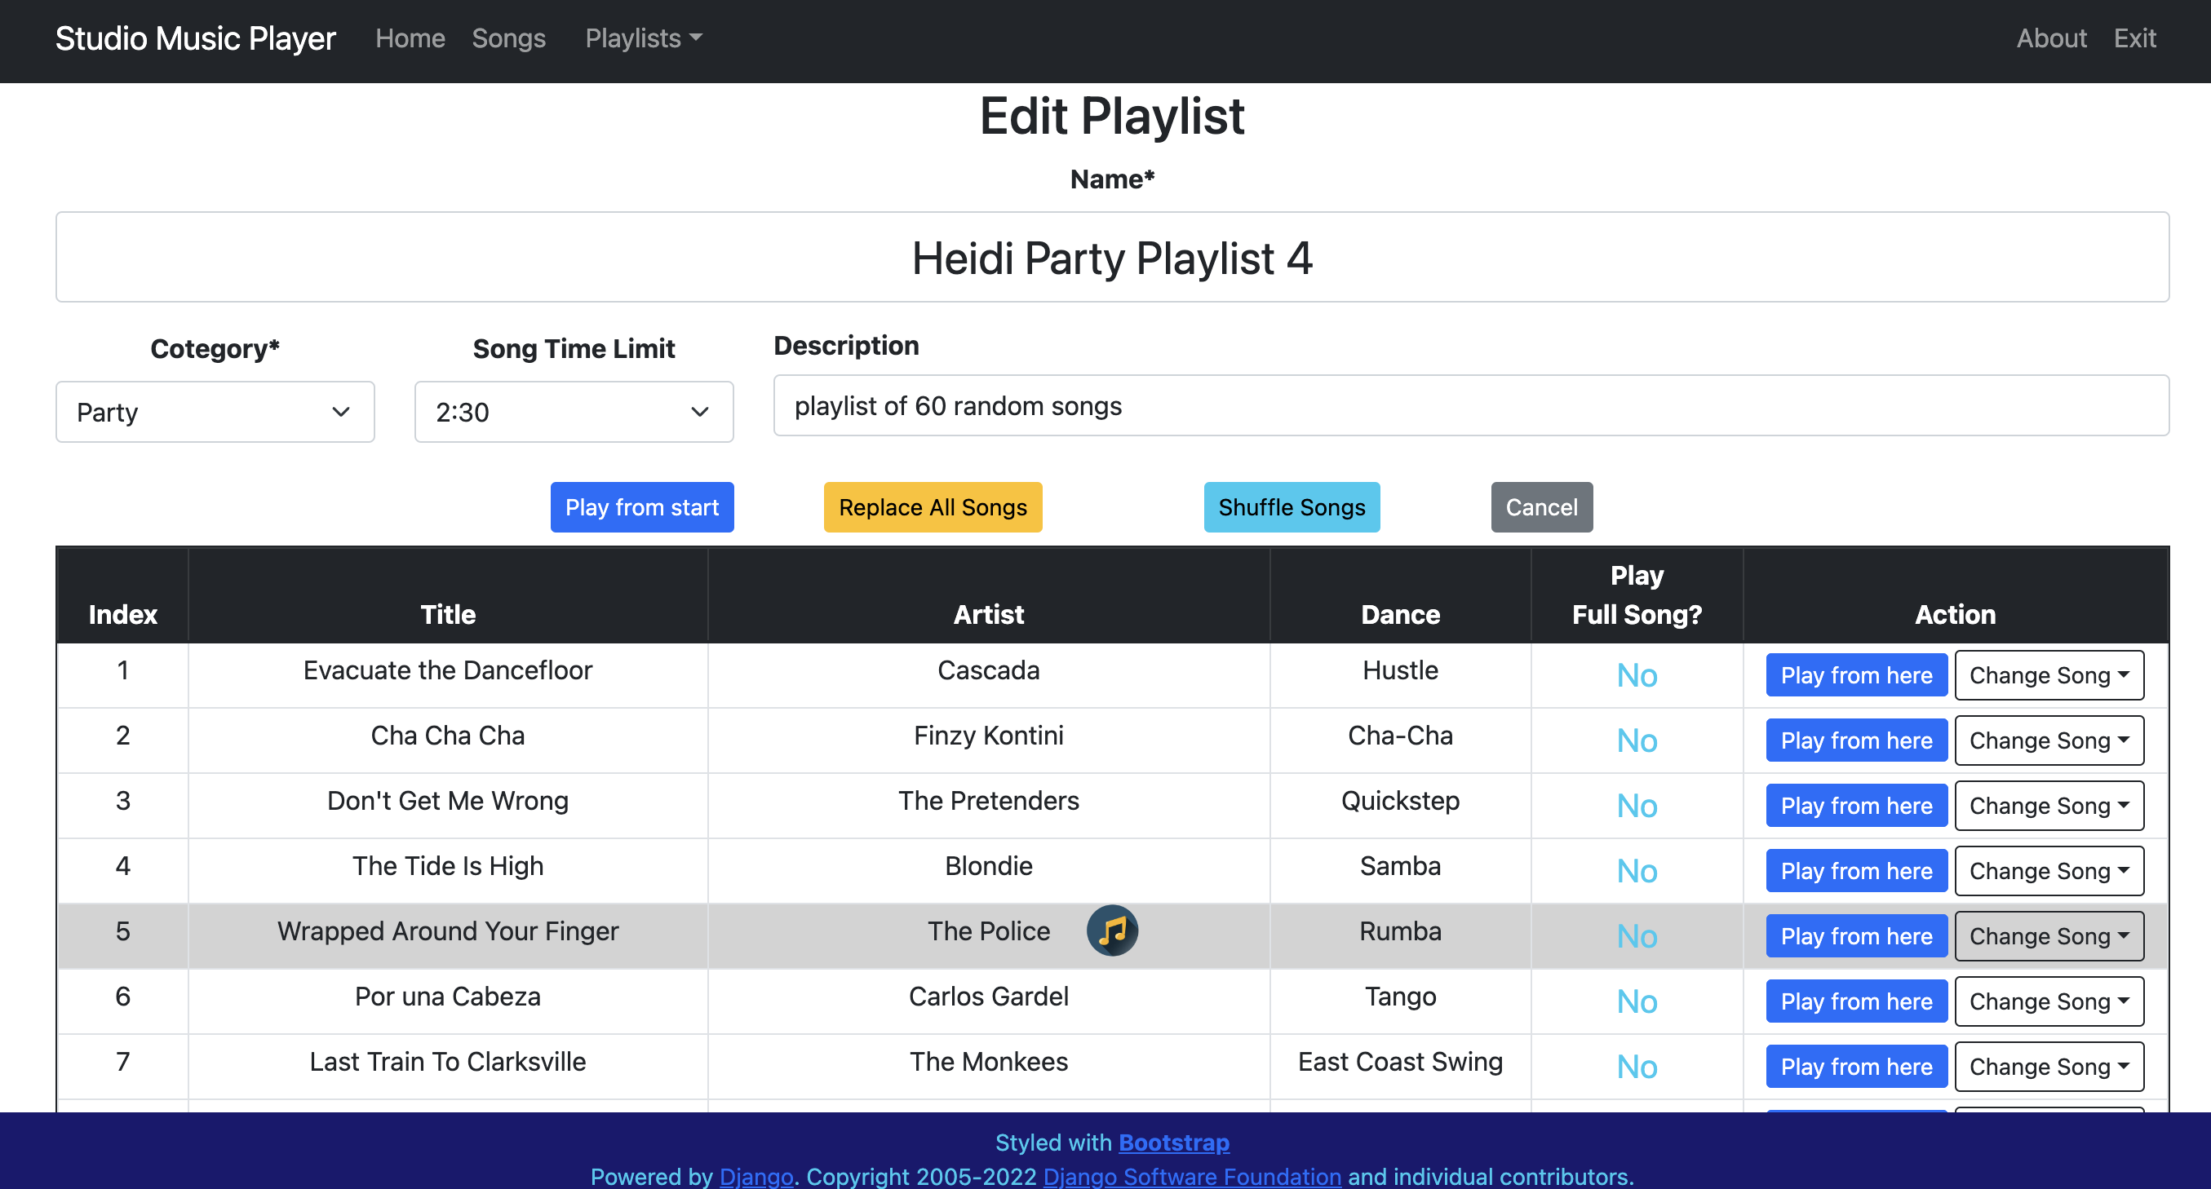

Figure 48 - Selecting a song to move within the playlist

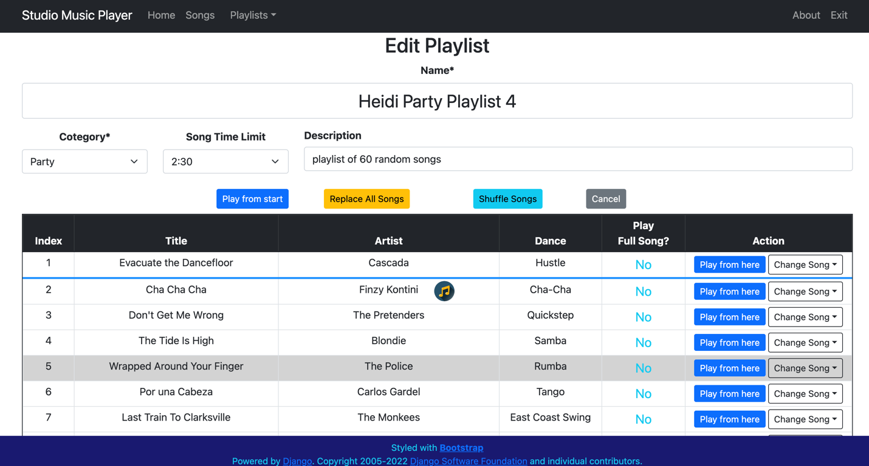

Figure 49 – Dragging the song toward its new position

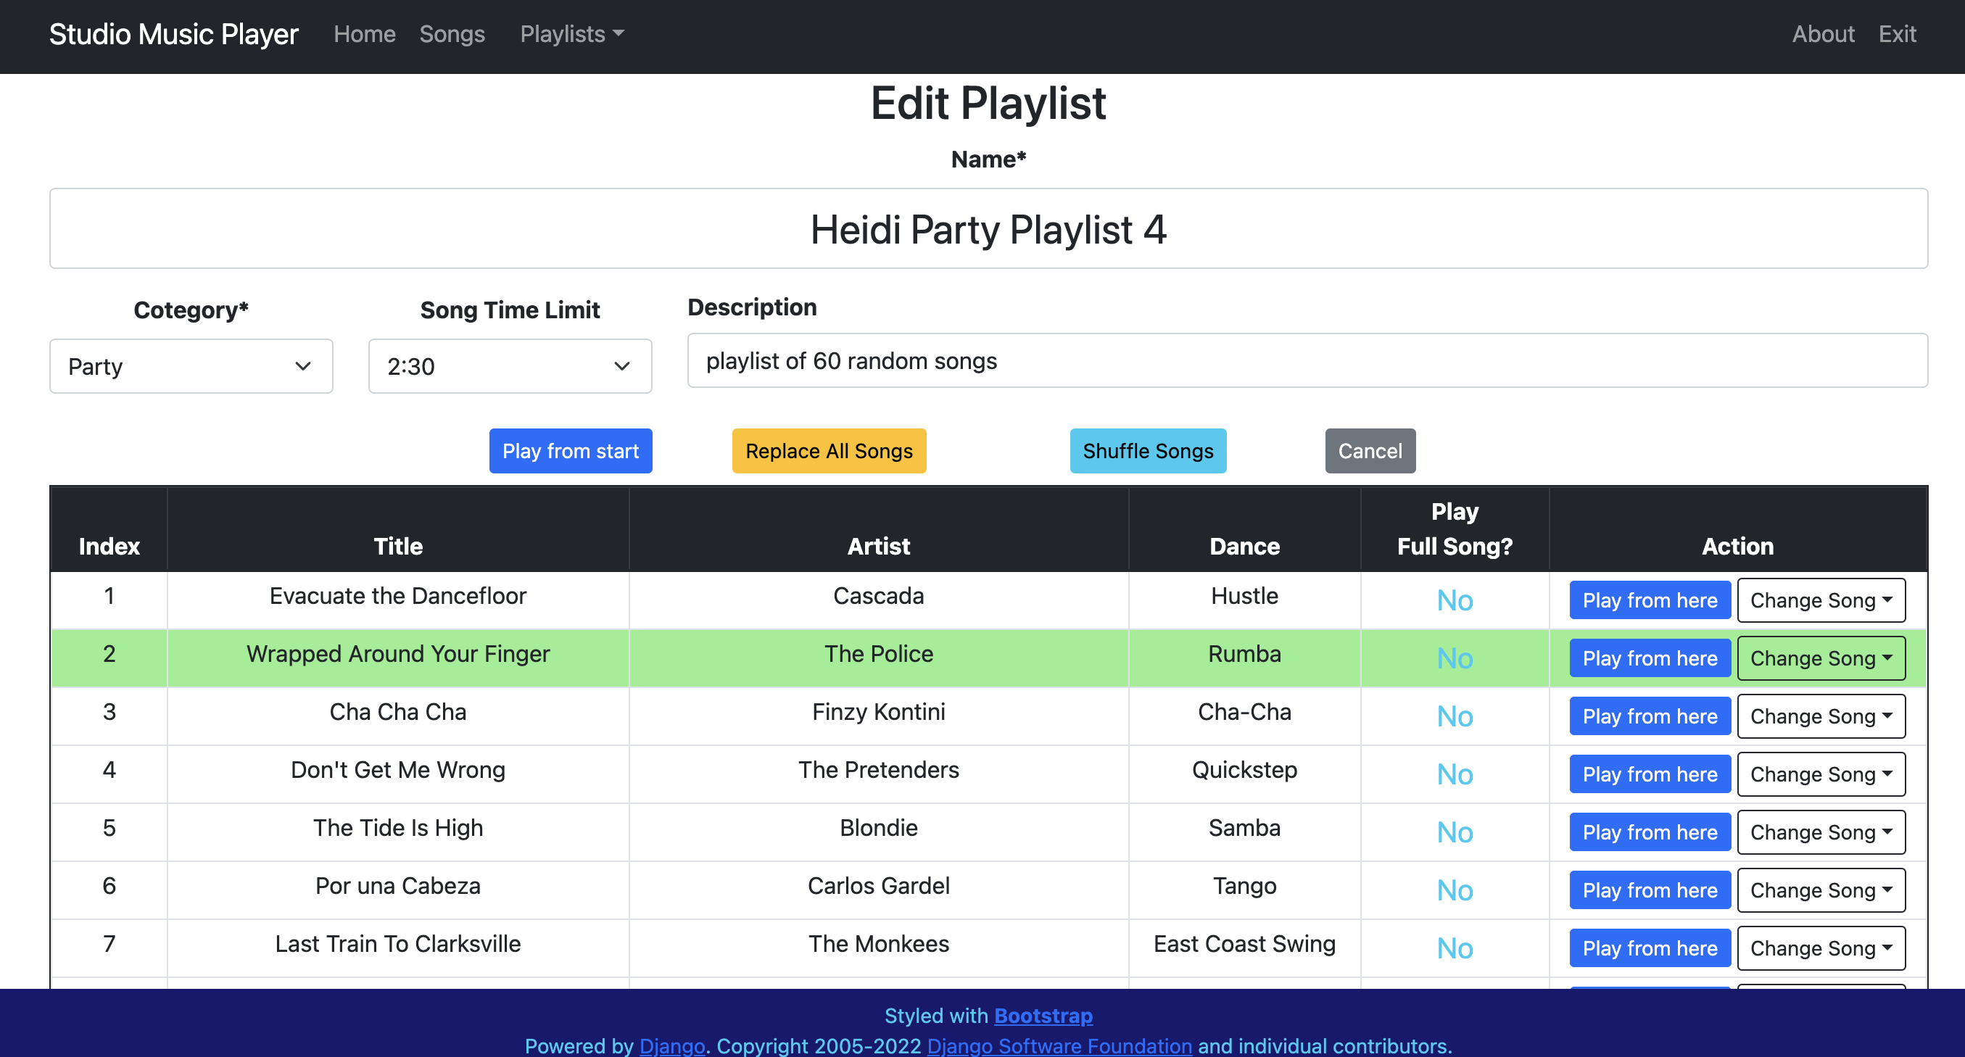

Figure 50 - Dropping the song at its new position

### Addtional playlist editing notes

To clear a highlighted row within the playlist, simply click the mouse button on any row of the song table and immediately release the mouse button.

### Stop editing the playlist

While on the Edit Playlist page, if the user has no more changes to make, they can click the Cancel button to return to the User Playlists page.

### Starting a playlist

There are various ways to start playing a playlist.

1. On the User Playlist or All Playlist pages, clicking the **Play** button in any row of the table will start the playlist at the specified song index (default is 1). See Figure 34.
2. On the Edit Playlist page, clicking the **Play From Start** button will start the playlist at the first song. See Figure 50.
3. On the Edit Playlist page, clicking the **Play From Here** button in any row of the table will start the playlist at the song index associated with that row. See Figure 50.

Once a playlist is started by any of the methods above, the Playlist Player screen is displayed as shown in Figure 51.

#### Party Playlists

This example is a party playlist, as indicated by a dark blue background. For a Party playlist, the user can hit Play and walk away as the next song is played automatically.

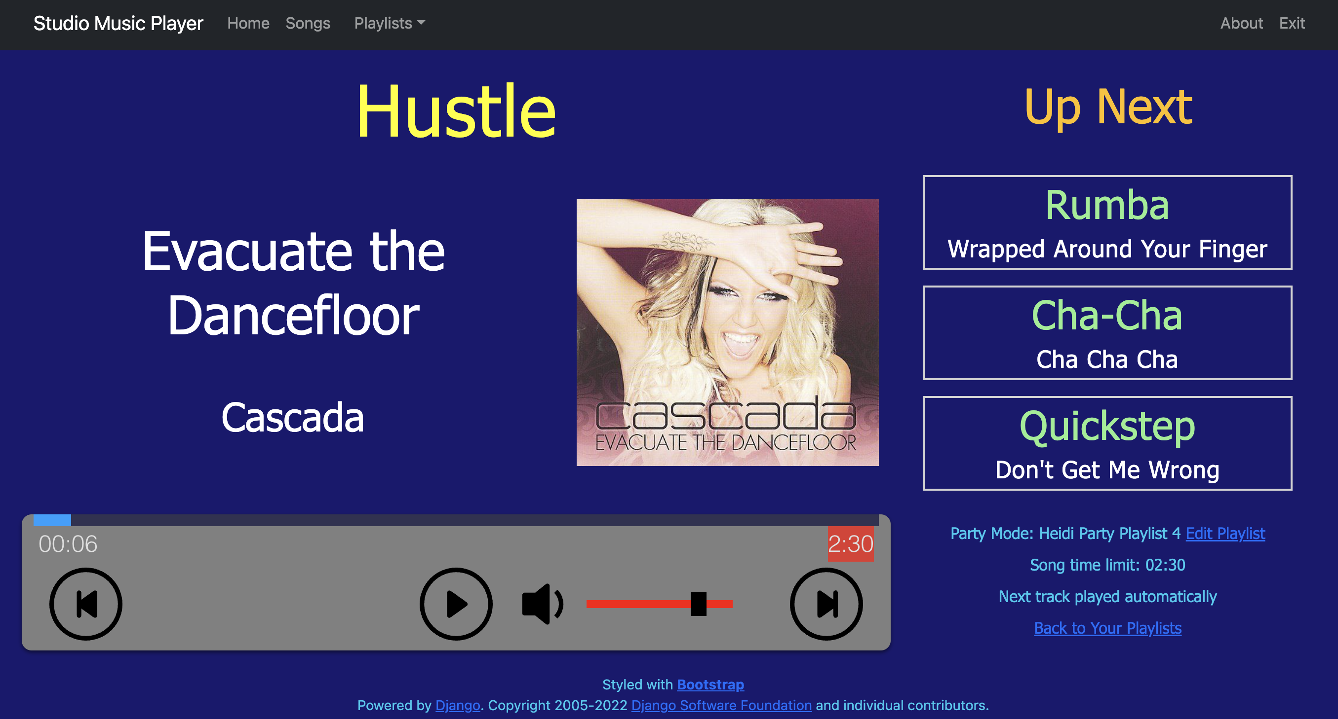

Figure 51 – Party Playlist player

As on the Single Song Player, the dance style, title, artist, and cover art (if available) of the current song are shown prominently.

The Up Next section is unique to the Playlist Player. It indicates the dance style and title of the next three songs within the playlist.

The fine print section at the lower right corner of the screen contains the following information:

* The playlist category and title are listed with a link to the Edit Playlist page for this playlist. Clicking the link stops the playlist and takes the user to that page.
* The song time limit for the playlist is shown. A few seconds before the limit is reached the volume begins to fade and this notice is highlighted in red until the time limit is reached.
* The next track status of this playlist, automatic vs. manual, is indicated
* There is a link to the user’s playlist page. Clicking the link stops the playlist and takes the user to that page.

The Play / Pause circular icon works the same way as the Single Song Player.

The Previous and Next circular icons are unique to the Playlist Player and work as follows:

* If a song is currently playing
  + the Previous button restarts the current song
  + the Next button will start playing the next song in the playlist
* If a song is currently paused
  + the Previous button will go to the previous song in the playlist and remain paused
  + the Next button will go the next song in the playlist and remain paused.

The volume slider and mute button work the same way as the Single Song Player, but they are not typically used because of the automatic volume fading implemented in the Playlist Player

The progress bar works similar to the Single Song Player. The song time limit is shown in red on the right side of the progress bar.

#### Normal Playlists

Normal playlists are indicated by a dark red background, as shown in Figure 52. For a Normal playlist, the user can hit Play and walk away as the next song is played automatically.

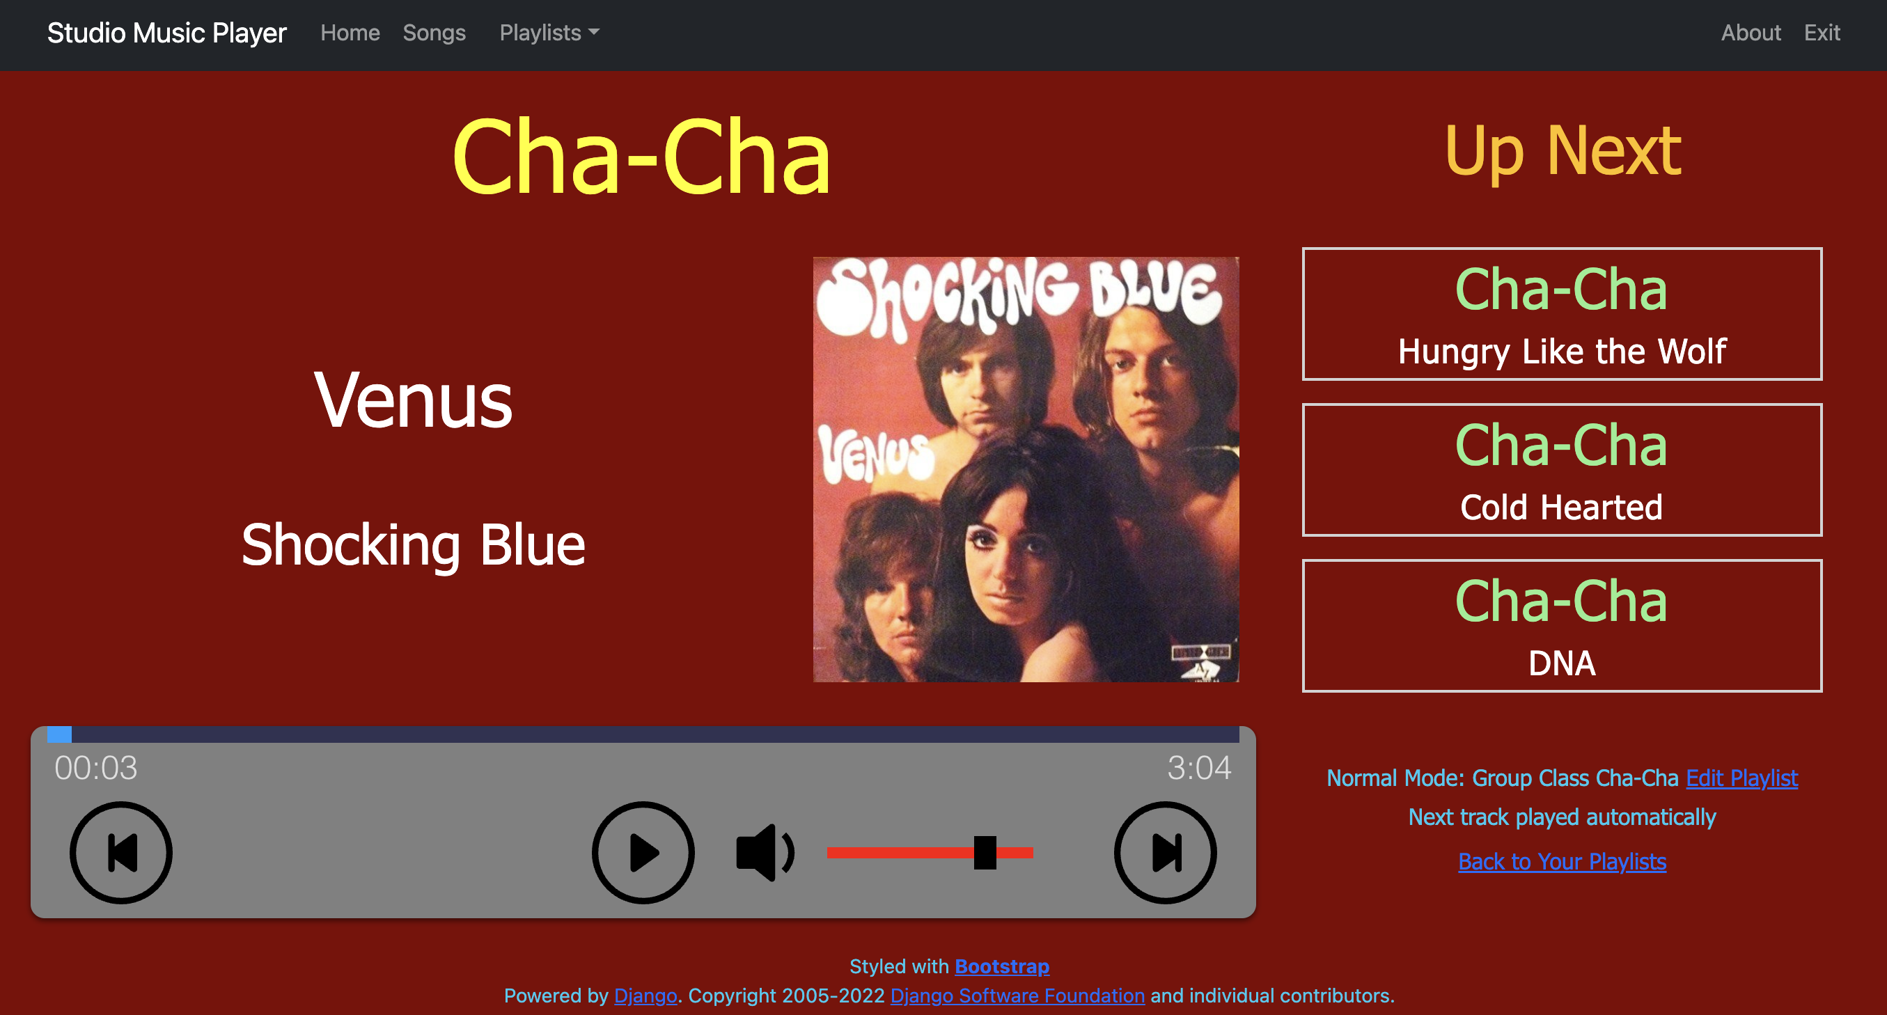

Figure 52 - Normal Playlist Player

The only differences between Normal Playlists and Party Playlists are:

* Normal playlists always play the entire song and there is no volume fading.
* Because there is no song time limit, that line is missing from the lower right section of the screen.

#### Showcase playlists

Showcase playlists are indicated by a dark gray background, as shown in Figure 53. Showcase playlists have a song time limit which works the same way as a Party Playlist.

The differences between Showcase Playlists and Party Playlists are:

* Showcase playlists stop after each song is complete, and the user decides when to start playing the next song.
* Showcase playlists display the heat number in addition to the dance style.
* Showcase playlists do not display the song title in the Up Next section.

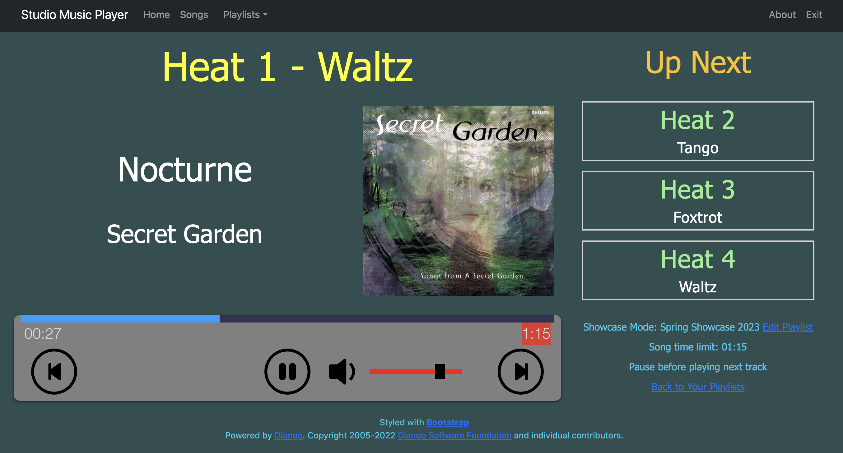

Figure 53 - Showcase Playlist Player

When a song in a Showcase Playlist nears the time limit, the volume fades in the same way as a Party Playlist. When the song reaches the time limit, the Showcase Player advances to the next song, but does not start playing, as shown in Figure 54.

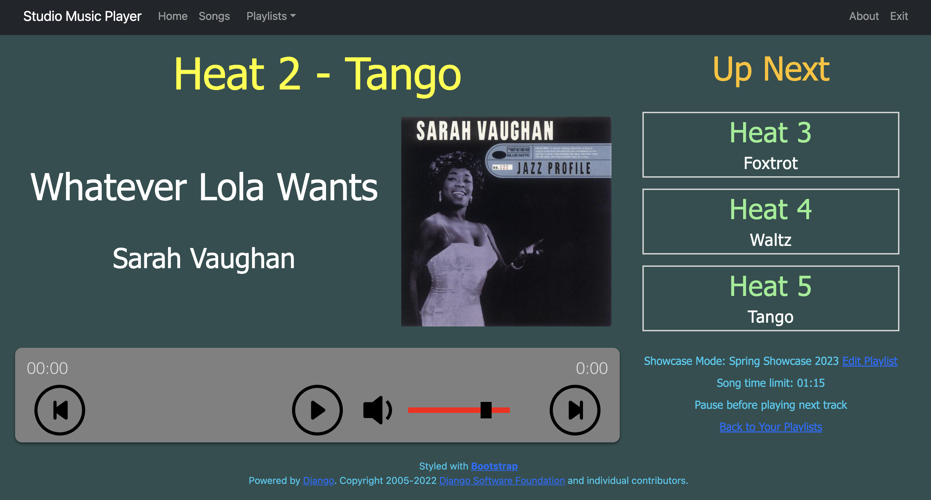

Figure 54 – Showcase Player paused between songs – hit Play to continue

**Once the user is ready for the next heat, they click the Play circular icon to start playing the song for that heat.**

#### Feature Songs

Showcase playlists have the concept of Feature Songs, which are used for solos and showdances where the couple supplies their own music.

Feature Songs ignore the maximum time limit and play the entire song without any fading.

Once the audio file for the solo has been added to the Studio Music Player, it can be included in the Showcase Playlist.

If the showcase program includes general dancing, Feature Songs can be used to reserve that space in the Showcase playlist.

As shown in Figure 55, the Edit Playlist page for Showcase Playlists includes a Play Full Song column with values of Yes or No. Yes indicates that this row is a feature song. Clicking the Yes or No for a row changes that row to the other setting.

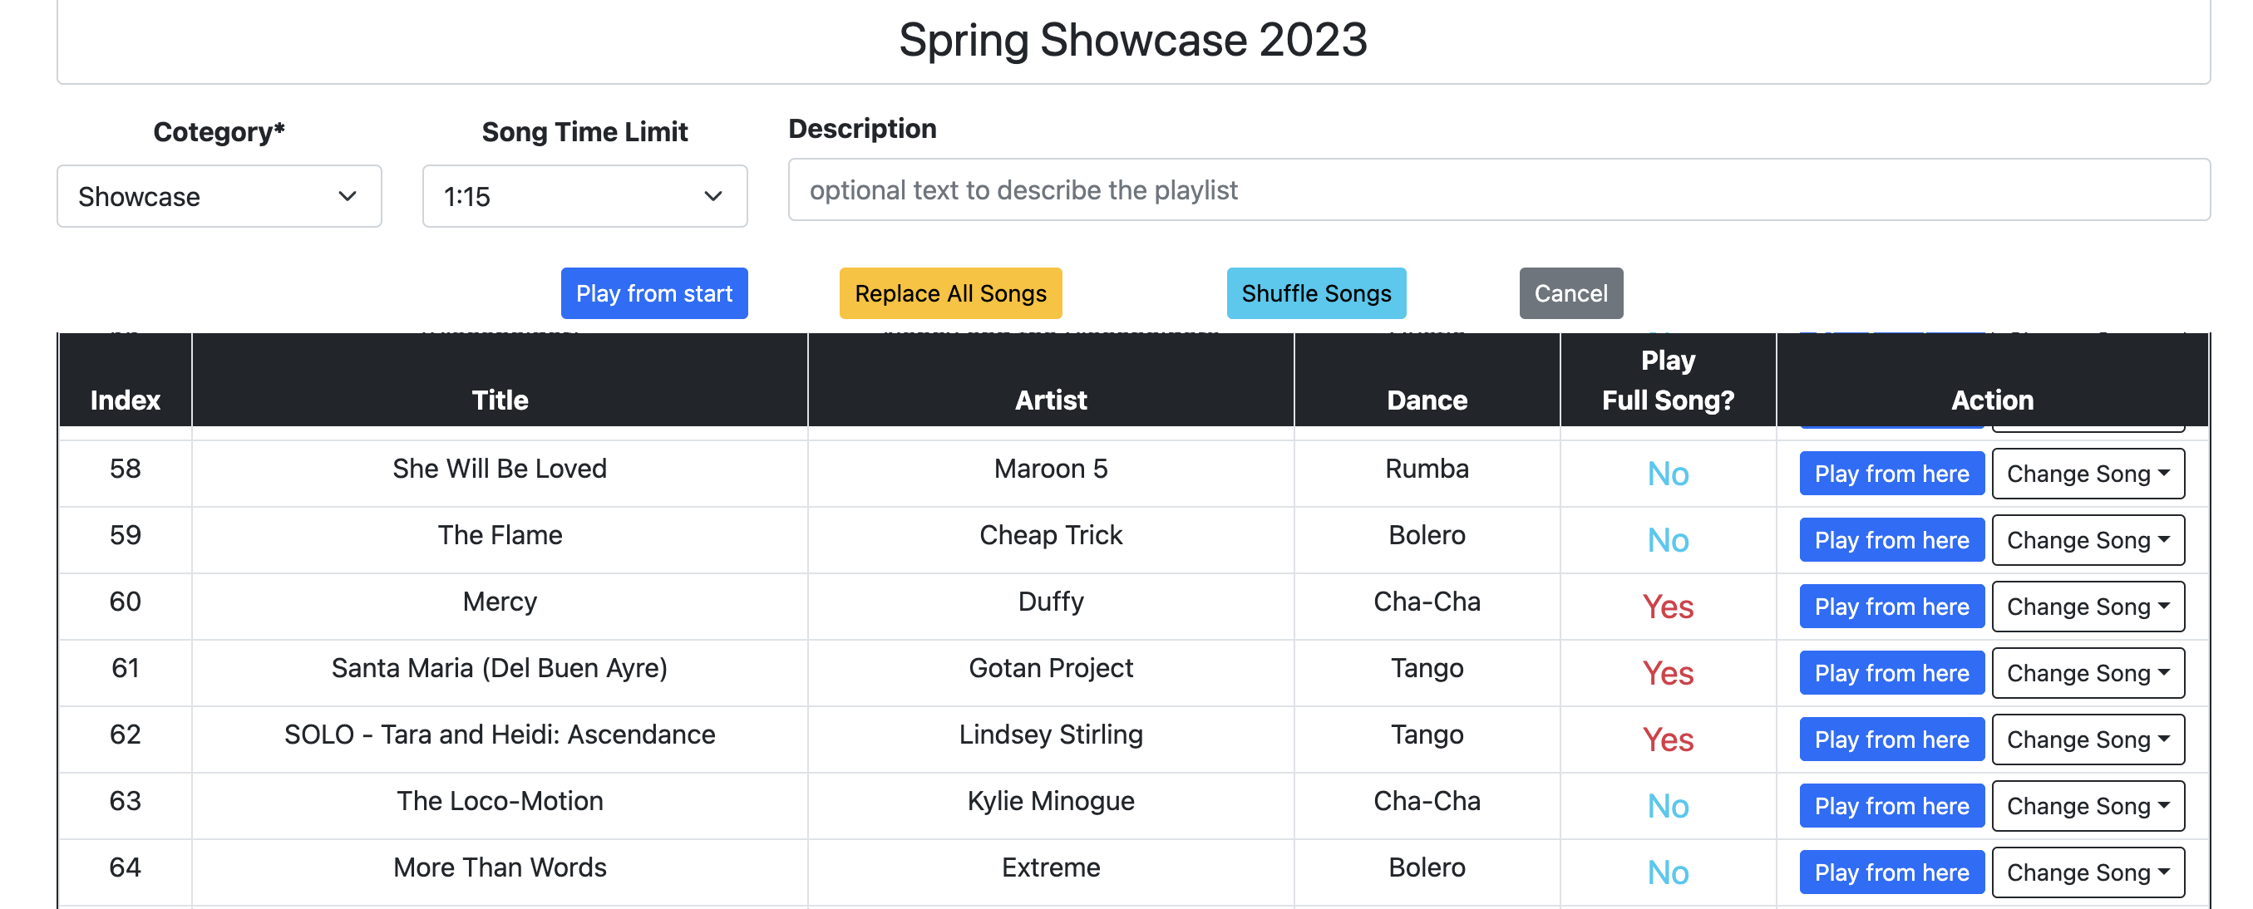

Figure 55 - Feature Songs in a showcase playlist

# STREAMING FROM SPOTIFY

Note that the device must have an active internet connection to use all Spotify features described in this section.

## Sign in to Spotify

When the user clicks the Sign in to Spotify button, if they are not currently signed into Spotify on this device, they will be redirected to the Spotify website, as shown in Figure 56.

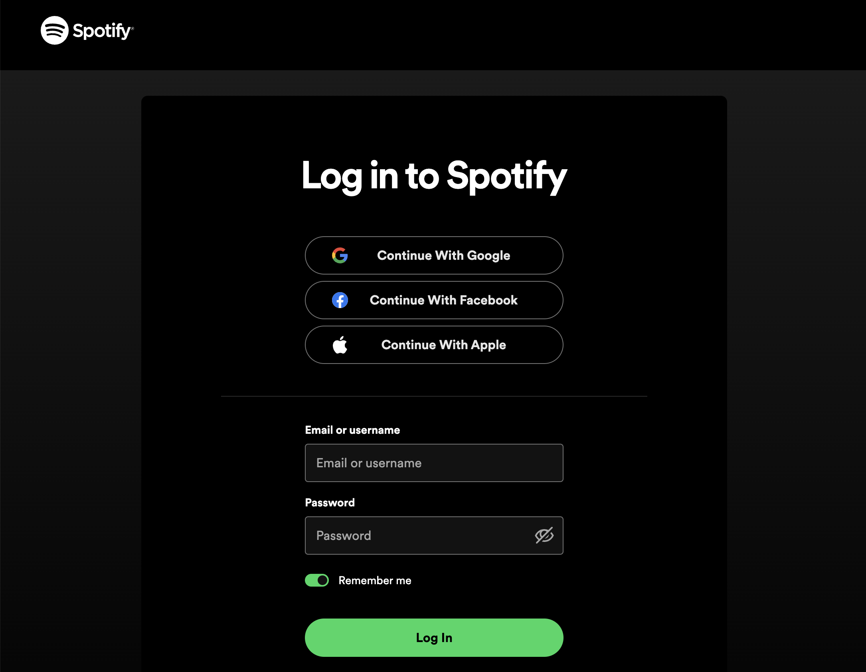

Figure 56 - Enter Spotify credentials

Once the credentials are authenticated, the user will have to provide permission for the Studio Music Player application to access their Spotify account by clicking the **Agree** button, as shown in Figure 57.

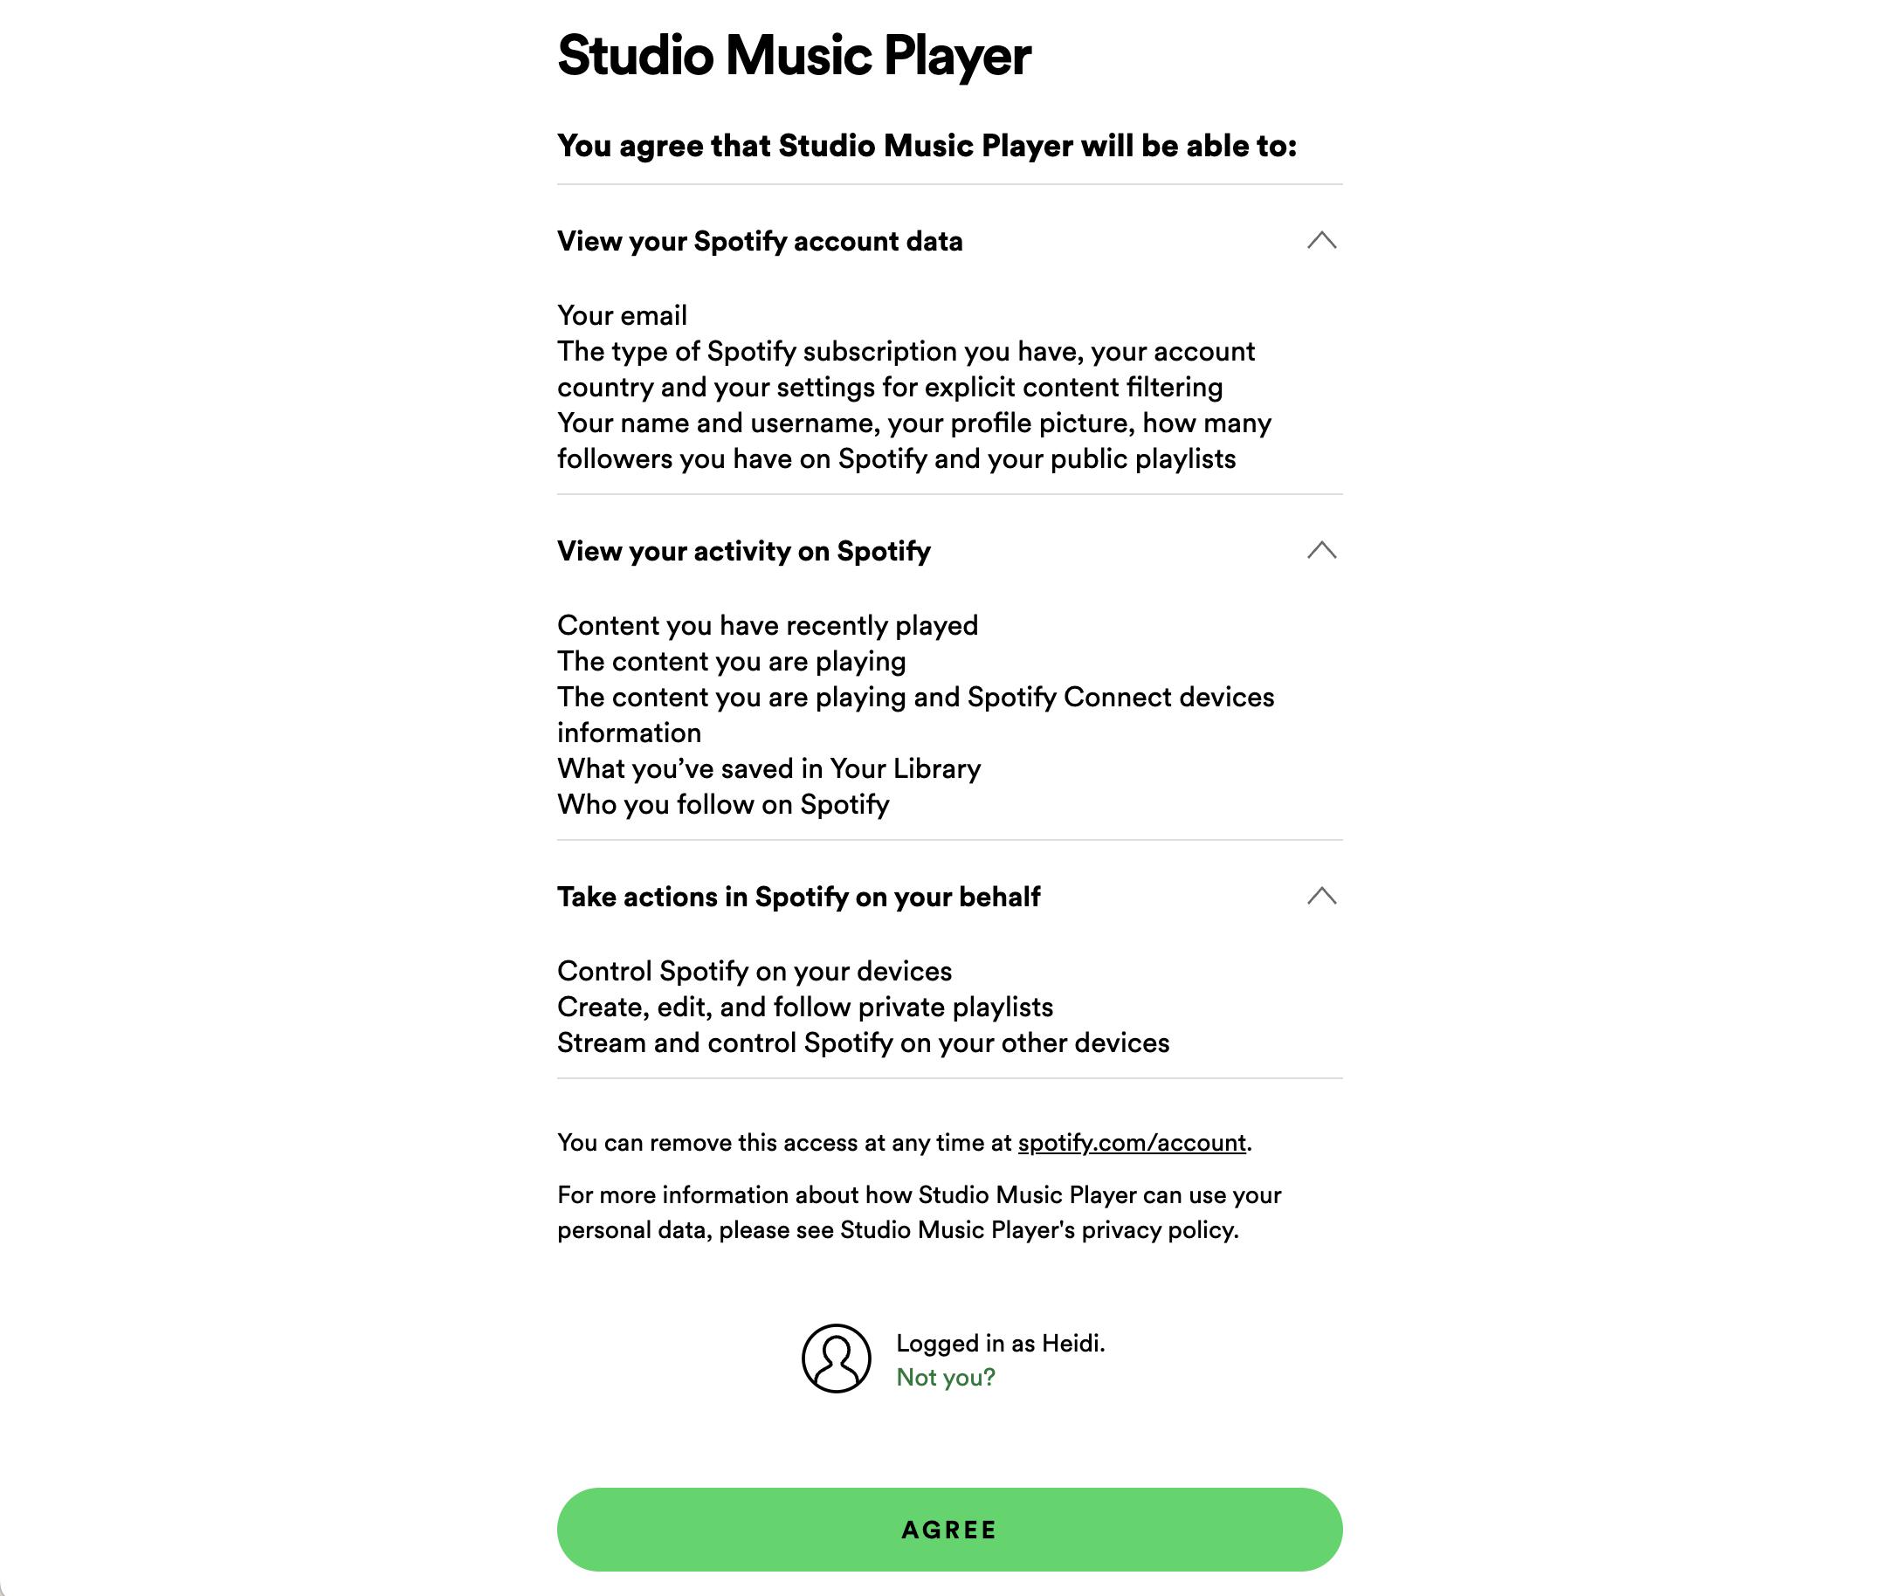

Figure 57 - Allowing access to Spotify account

Once the **Agree** button is clicked, if the user was using Spotify to look up BPM information for a song on the local device, they will be returned to either Figure 23 (BPM info found) or Figure 24 (BPM info not found).

If the user has selected to stream from Spotify, a list of their liked songs is displayed, as shown in Figure 58. Also note that an additional menu item named Find tracks on Spotify is included in the Navigation Bar.

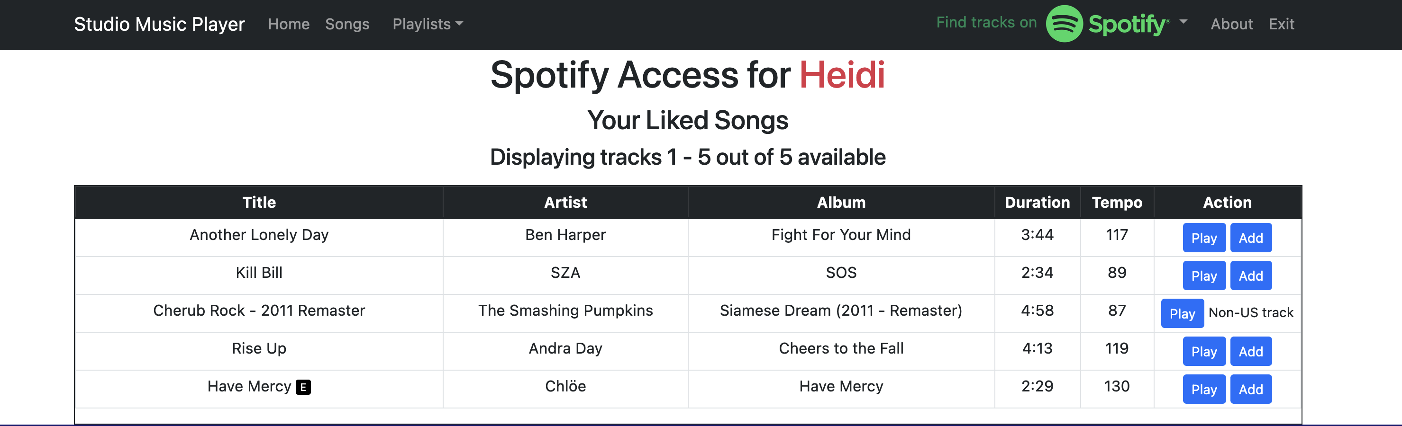

Figure 58 - List of Liked Songs on Spotify

## Find tracks on Spotify

This section to be added in the future.